Basics of Language:-

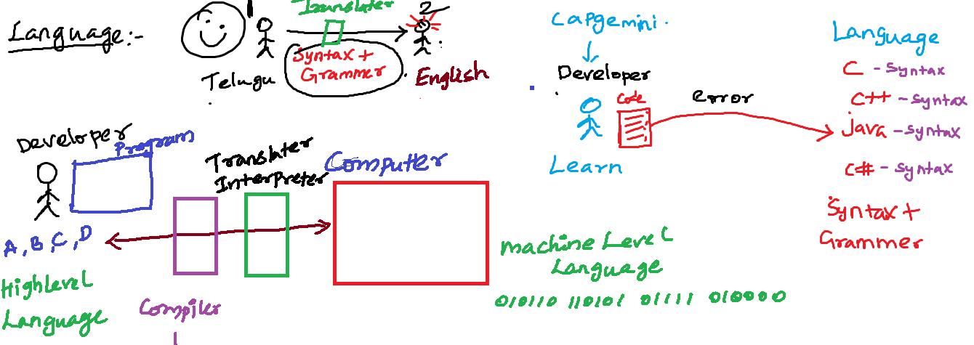

Eclipse IDE:-

Workspace:

It is a folder contains one or more related java projects.

Project:-

It is a folder. It contains one more files related to that project

One or more java files

JRE System Library:-

Has all predefined java classes

Src :-

All user defined .java file must be place inside the src folder

Build -> javac filename.java

Run -> java filename

JDK

JRE

JVM

Sample.class 🡪 JRE 🡪 Machine code(output)

Sample.class 🡪 JDK(JRE), JRE 🡪 Machine code(output)

Sample.java🡪 JDK 🡪 Sample.class🡪 JRE🡪 Machine code(output)

.apk(.classes)

|

Phone (JRE)

|

Machine (Output)

Identifiers:-

All words in java. It is called as identifier

Reserved Keyword or User Defined Keyword

package name, class name, method name, variable name

Package Name:

* All letters must be in lower case
* Should not contains any space

Variable Name:-

* A java variable can start contain (a-z A-Z 0-9). Special character _ $
* Variable name should starts with a character(a-zA-Z _ $).
* It should not start with a number
* Variable name should be meaning full name
* If the variable is constant variable then variable name must be capital letter
* If variable name is single word all letters must be smaller case
* If variable name contains more than one word then first word all letter smaller second word onwards each word first letter must be capital

Method name:-

* If method name is single word all letters must be smaller case followed by bracket()
* If method name contains more than one word then first word all letter smaller second word onwards each word first letter must be capital then followed by ()

Class names:-

* Class name each word starting letter must be in capital all the remaining letters in lower case

Interface Name:-

* interface name each word starting letter must be in capital all the remaining letters in lower case

class Syntax:-

package <packagename>;

import <packagename>;

accessmodifier class <classname>{

constructor

variable

methods

}

Class in java:-

A class contains related members

Members – Member variable, Member Functions

Class is template or blueprint of an object

Class is a container in which we write related variable and methods (Encapsulation)

Object Oriented concept:-

Class and Objects:-

Why Functions?

Execute some logic or task

1. Function without arg without return value

**public** **void** multiply() {//perform task or logic

**int** a=29;

**int** b=45;

**int** c=a*b;

System.***out***.println(c);

}

1. Function with arg without return value

**public void add(int a,int b) { //perform task or logic**

**int c=a+b;// logic**

**System.out.println(c);**

**}**

1. Function without arg with return value
2. Function with arg with return value

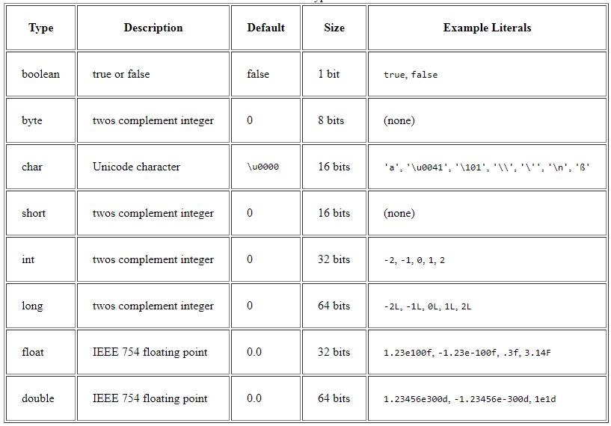

Variable in java:-

Variable is an identifier for the memory location

Variable declaration

Datatype variablename;

Variable initialization

Variablename=value;

String name= “rajesh”

String rollno;

String year;

String sem;

int phone;

String email;

float cgpa;

rajesh, 3555SF, IV, VIII, 445454, [rajesh.kit@gmail](mailto:rajesh.kit@gmail), Chennai, 6.4

Types of variables:-

1. Instance variable
   1. Declared inside the class and outside of any method in the class without static keyword
2. Local variable
   1. A variable declared inside the method or block
3. Static variable
   1. Declared inside the class and outside any method with static keyword
4. Reference variable

Types of methods:-

1. Instance method OR non static method
2. Static method OR non instance method

Packages:-

Collections of related java classes, interfaces and enums.

Avoid the naming conflict

Variable declare:-

---------------------------

Accessmodifier Nonaccessmodifier datatype variable;

Class declaration:-

---------------------------

Accessmodifier Nonaccessmodifier class classname{

}

Function:-

Accessmodifier nonaccessmodifier returntype functionName(arg){

-----------------;

-----------------;

}

Access modifiers:-

private, default, protected, public

* Can be added before variable, method, class , interface

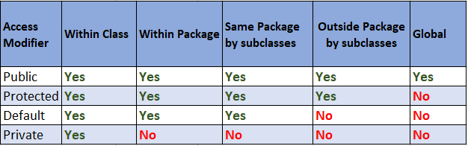

Non-Access Modifiers:-

Non access modifiers changes the default behaviour

Final, static, abstract, synchronized, volatile, native, transient

int mark=100;

Variable initialization:-

* Local variable -> while declaring a local variable we must initialize the value
* Instance or static variable
  + During variable declaration you can initialize

Flow Control

Conditional control statement

If, if else, if elseif, switch

If:-

if(condition){

statements;

}

Un-Conditional Control Statement

Break, label

{

}

Block – grouping set of statements

switch(condition or choice){

case label:

statements;

case label:

statements;

case label:

statements;

default

statements;

}

Java Operators:-

Assignment Operator

Int a+10;

Relational Operator -> comparing between values. It always returns a Boolean true or false

10>20 -> false

10>=20 -> false

10<20 -> true

10<=20 -> true

<,<=,>,>=,==,!= or <>

Arithmetic Operators

+,-,/,*,%

Conditional Operator:-

(condition) ? value1 : value2; if(condition){

Statements

Else{

statements }

logical operators:

&&, ||, !

Control Statements:-

You can control statement or flow of statement execution

Conditional Statements:- if, if..else, if..elseif..else, switch

Un Conditional Statement:- break, continue, label

Looping statement:-

One or more java statement can be executed finite no of times. You have to loops

For, while , do..while, advanced for loop

For loop:-

for (initialization;condition;increment/decrement){

statements;

}

Advanced for loop:-

-----------------------------

for(datatype variablename:arrayname){

statements;

}

Instance of Operator:-

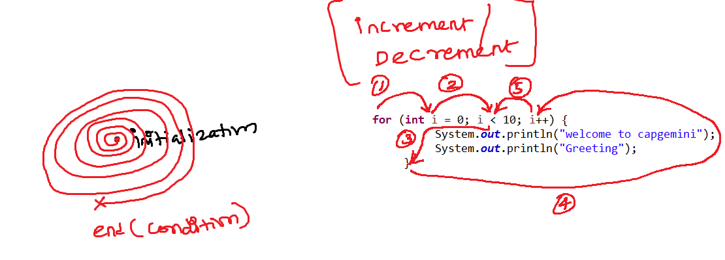

while loop:-

while(condition){

statements;

}

do while:-

initiliaztion

do{

statements;

increment/decrement;

}while(condition);

break and continue

Unlabelled break and Unlabelled continue

labeled break and labeled continue

Array:-

Group of similar data stored in a single variable is called as array

Array index starts with zero end with size-1

Eg:-

int[] mark=new int[] {46,34,67,23,78,89};// primitive array

String[] city=new String[] {"","","","",""};// reference type array - String predefined class

Employee[] employees=new Employee[] {e1,e2,e3,e4,e5,e6};//reference type array - Employee userdefined class

Object Programming:-

Classes:-

Encapsulation – data (variable) and the code (method) together kept inside the class it is called encapsulation

Putting all variable and the method inside the class

To make perfect encapsulation

All variable you need to keep it as private

Create a public getter and setter method through which other programs can

Access your data

Inheritance can be achieved in two ways:-

Is-a inheritance

If you use **extends or implements** keyword to do a inheritance

Has-a inheritance

If you create an **reference** of one class into another class

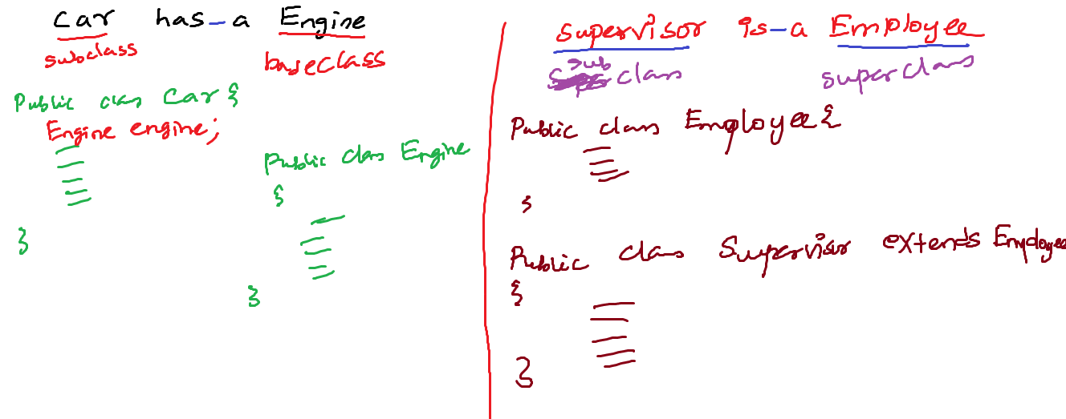

Polymorphism:-

More than one form

A task can done more than one form

Send

Person A -----------------------------------------------------------🡪 Person B

SendParcel (courier)

SendParcel (speedpost)

SendParcel (friends)

SendParcel (myself)

findArea:-

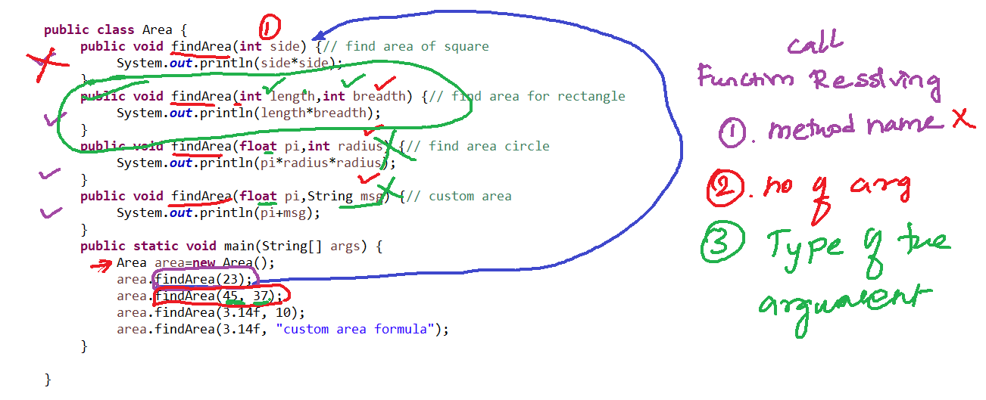

Function call resolving or method binding:-

For the function, call which method implementation or definition get executed decision-making is called function call resolving

If any conflict comes in the function call resolving

The function call resolving decision will be made based

1. Method name
2. No of arguments
3. Type of the arg

Function with same different argument in same or different class it is called as method overloading

Function with same same argument in different class it is called as method overriding

Abstraction:-

Hiding the implementation and showing the essential information is called abstraction

Car has very complex many mechanical parts, as you need to know how to drive the car

Ex:1

**public** **void** findArea(**float** pi,**int** radius) { System.***out***.println(pi*radius*radius);

}

This Implementation show all the details it is not abstraction

If method does have any implementation, it is called concrete method or implemented method or non-abstract method

Ex:2

**public** **void** findArea(**float** pi,**int** radius);

It is not the complete implementation and it is showing only the essential information (abstraction)

If method does not have any implementation, it has only the declaration. Abstract method or unimplemented method

Two ways you can implement abstraction:-

1. Abstract class - 100% abstraction
   1. Abstract class does not allow you to create object but you can inherit the abstract class

To other classes

1. Interface – 100% abstraction

If all the methods abstract method

For the abstract class and interface, you cannot create an object. But you can create reference variable

|  |  |
| --- | --- |
| Abstract Class | Interface |
| 1. Abstract class can have concrete or implemented methods | Interface can have abstract method or unimplemented methods |
| 1. An abstract class should have minimum one abstract methods may have zero or more concrete method | All the methods in the interface are abstract methods |
| 1. Inherit the abstract class to other child class **extends** keyword | Inherit the interface to child class **implements** the interface |
| 1. Abstract class methods need to explicitly add abstract keyword for abstract methods | All the method in the interface by default public abstract methods |
| 1. All the variable access modifier non access modifier default set by the developer | All the variable declared in the interface by default public static final variable |

A Class member:-

1. Member variable
2. Member function or method
3. Constructor
   1. Constructor is similar to your member function. It is special function that should not contain the return type and the name should be similar to your class name.
   2. Constructor will be called automatically. When we create an object for the class. Right after the object is got created then the constructor will be automatically

Constructor overloading

* A constructor with the same name and diff argument or parameter is called constructor overloading

No arg constructor

Arg constructor

Default no arg constructor

//jvm is going add one no arg constructor automatically by default during excution no arg default constructor

// jvm default no arg constructor it will all the instance and static variable and it initiliaze with the default values

Casting:-

Primitive Type Casting

* Primitive type
  + Converting one primitive to other primitive type it us called as primitive type casting
    1. Implicit type Casting or widening

byte – 1 byte – 8bits

short – 2 bytes – 16 bits

int – 4 bytes – 32 bits

long – 8 bytes – 64 bits

float – 4 bytes – 32 bits

double – 8 bytes – 64 bits

char – 2 bytes – 16bits

boolean – 1 bit

Explicit type Casting or Narrowing

Object Type Casting

* Object Type
  + Converting One object type to another Object type it is call Object type casting
    - 1. Implicit Object Casting or widening

Taking child class object reference and assigning into a parent class object reference

* + - 1. Explicit Object Casting or Narrowing

Taking parent class object reference and assigning into a child class object reference

Wrapper classes:-

A Object or reference type of primitive value

Primitive types (Wrapper classes)

byte – 1 byte – 8bits ----🡪 Byte

short – 2 bytes – 16 bits ----🡪 Short

int – 4 bytes – 32 bits ---🡪 Integer

long – 8 bytes – 64 bits ----🡪 Long

float – 4 bytes – 32 bits ----🡪 Float

double – 8 bytes – 64 bits ---🡪 Double

char – 2 bytes – 16bits ----🡪 Character

boolean – 1 bit ---🡪 Boolean

**Converting primitive type to the reference type or object type, we can do it by wrapper classes**

**Collection in java -> upcoming topic**

**Collections in java always deals with the object or reference types not with the primitive type**

**As a programmer -🡪 as a primitive type**

**User 🡪 Input 🡪 primitive type**

**public** **static** **void** main(String[] args) {

**int** salary = 10;

// Way 1:// convert primitive int type to the ref type

Integer iSalary = **new** ~~Integer~~(salary);

System.***out***.println(iSalary);

//Way 2:// convert primitive int type to the ref type

Integer i1=Integer.*valueOf*(10); // static method then we used to call the method using classname

System.***out***.println(i1);

**int** cSalary=i1.intValue();// converting reference Integer object into primitive int type

**int** icSalary = iSalary.intValue();

Integer ii=3456;// Autoboxing - automatically converts primitive value to reference type

**int** cc = ii; // autounboxing - automatically converts reference type into primitive type

**float** f=34.34f;

Float f1=Float.*valueOf*(f);

**float** f3 = f1.floatValue();

**char** ch='4';

Character c = Character.*valueOf*(ch);

**char** c1 = c.charValue();

}

Primitive type to reference type

Reference type to primitive type

String to a wrapper class reference type

String to a primitive type

Syntax error:-

Java exception:-

During the java code execution (Runtime), an abnormal condition will happen it is called **Java Exception**

**If exception is not handled it terminate the program execution abruptly** or immediately, it will allow to not execute the program further statements.

If the programmer handles an exception can terminate the program gracefully

Exception in thread "main" java.lang.ArithmeticException: / by zero

at exceptionhandlingdemo.Demo.main(Demo.java:9)

**----------------------------**

**Exception in thread "main" java.lang.NumberFormatException: For input string: "sfd20"**

**at java.base/java.lang.NumberFormatException.forInputString(NumberFormatException.java:65)**

**at java.base/java.lang.Integer.parseInt(Integer.java:652)**

**at java.base/java.lang.Integer.parseInt(Integer.java:770)**

**at exceptionhandlingdemo.Demo.main(Demo.java:10)**

**--------------------------------------------------**

**Exception in thread "main" java.lang.ArrayIndexOutOfBoundsException: Index 7 out of bounds for length 3 at exceptionhandlingdemo.Demo.main(Demo.java:12)**

**Exception Type - java.lang.ArithmeticException**

**Exception message - / by zero**

**Packagename.classname.methodname the line number where exception created**

**When an exception happens during the code, execution it will create java exception class object. That exception object has**

1. **Exception Type**
2. **Exception message**
3. **Packagename.classname.methodname the line number where exception created**

Java exception handle:-

1. Try catch

**Try block where you suspect the code can create an exception**

**try**{ //try block

}**catch**() {// catch block

}

**During the code execution finally block always gets executed whether the exception created or not created**

**finally**{ // finally block

}

1. Propagate the exception throws keyword

Upto jdk 1.6

After jdk 1.7

Java Exception:-

1. Checked exception

If the exception class extends Exception class its comes under the category of Checked Exception

1. Unchecked Exception

If the exception class extends RuntimeException class its comes under the category of Unchecked Exception

Own Exception or Custom Exception or User Defined Exception:-

============================================================

Bank – account no – “”, null – InvalidAccountNumberException

Money->negative–InvalidDenominationException  
 Aadhar No -> InvalidAadharNumberException

If my **exception class** extends **Exception** – **custom checked exception**

If my **exception class** extends **RuntimeException** - **custom unchecked exception**

String:-

Collection of characters are called as string

String name=”capgemini”;

char[] name=new char[9];

|  |  |  |  |  |  |  |  |  |
| --- | --- | --- | --- | --- | --- | --- | --- | --- |
| c | a | p | g | e | m | i | n | i |

Name

String is a predefined class

Strings are immutable (value will not changes)

Two ways to create a String

1. String literal (Immutable)
   1. String collegeName=”IIT”;
2. String class object(Immutable)
   1. String collegeName=new String(“IIT”);
3. StringBuilder(Muttable)
4. StringBuffer(Muttable)

Java IO Stream:-

Input

(System.in) Keyboard, browser, File 🡪 Java Program

Output

Java Program 🡪 console, browser(System.out), File

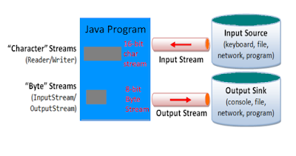

Two types of streams in java

1. Byte Oriented stream (0-128)

Read or write the binary form of data

Image, video, audio

Read -> InputStream

Write -> OutputStream

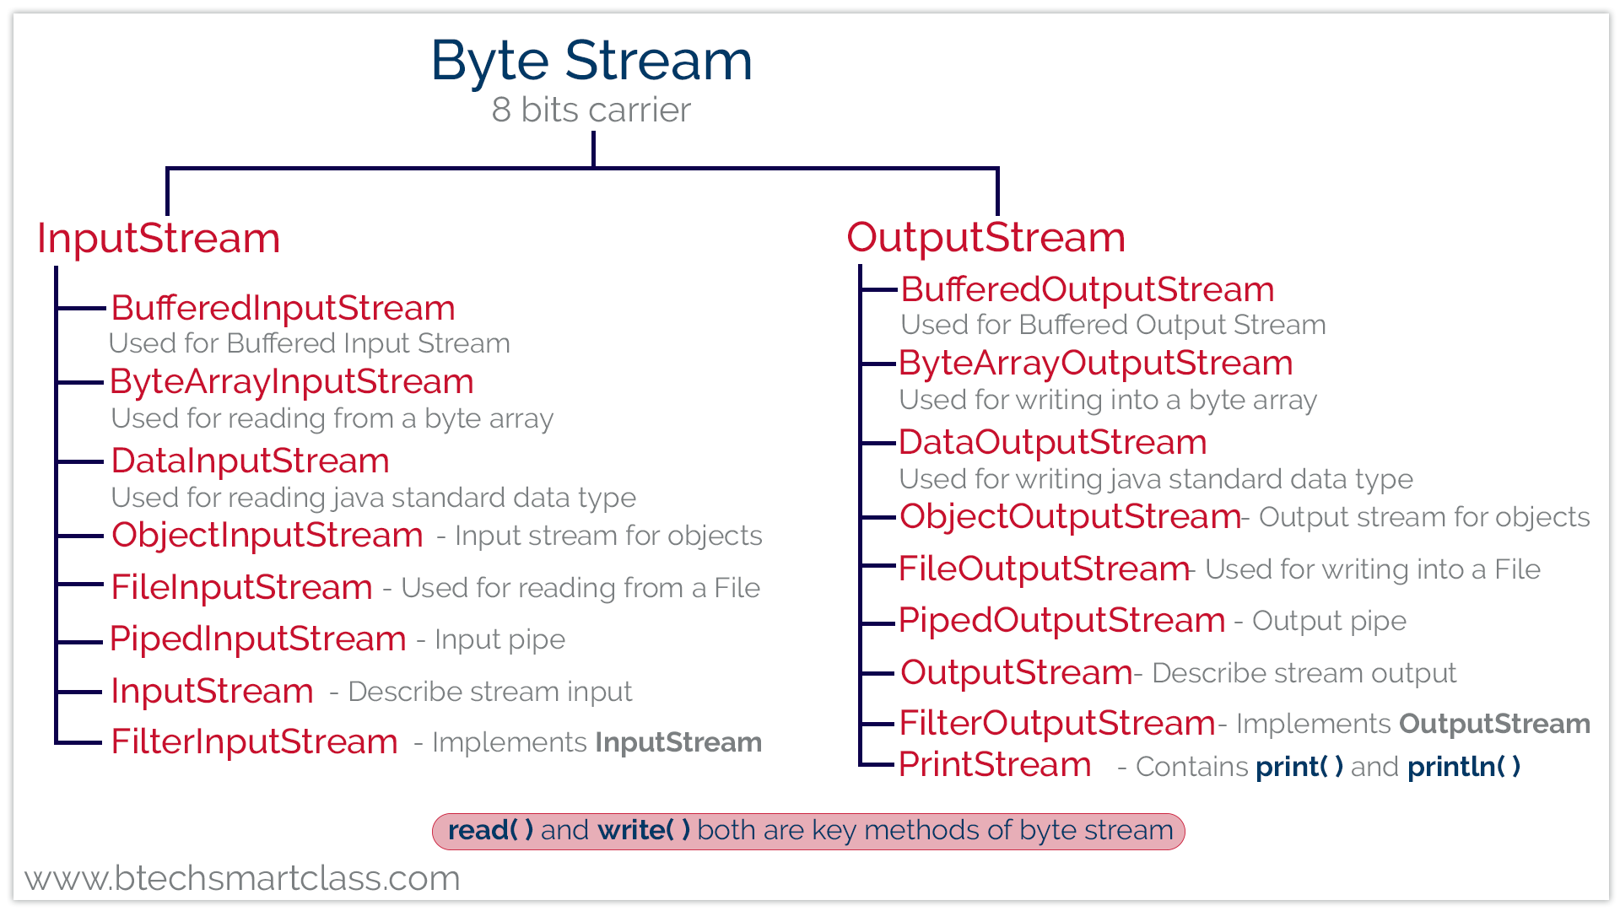

2.Character Oriented stream (0-256) – read / write

If you want to read text or character

Doc, xls, txt

Read -> Reader

Write -> Writer

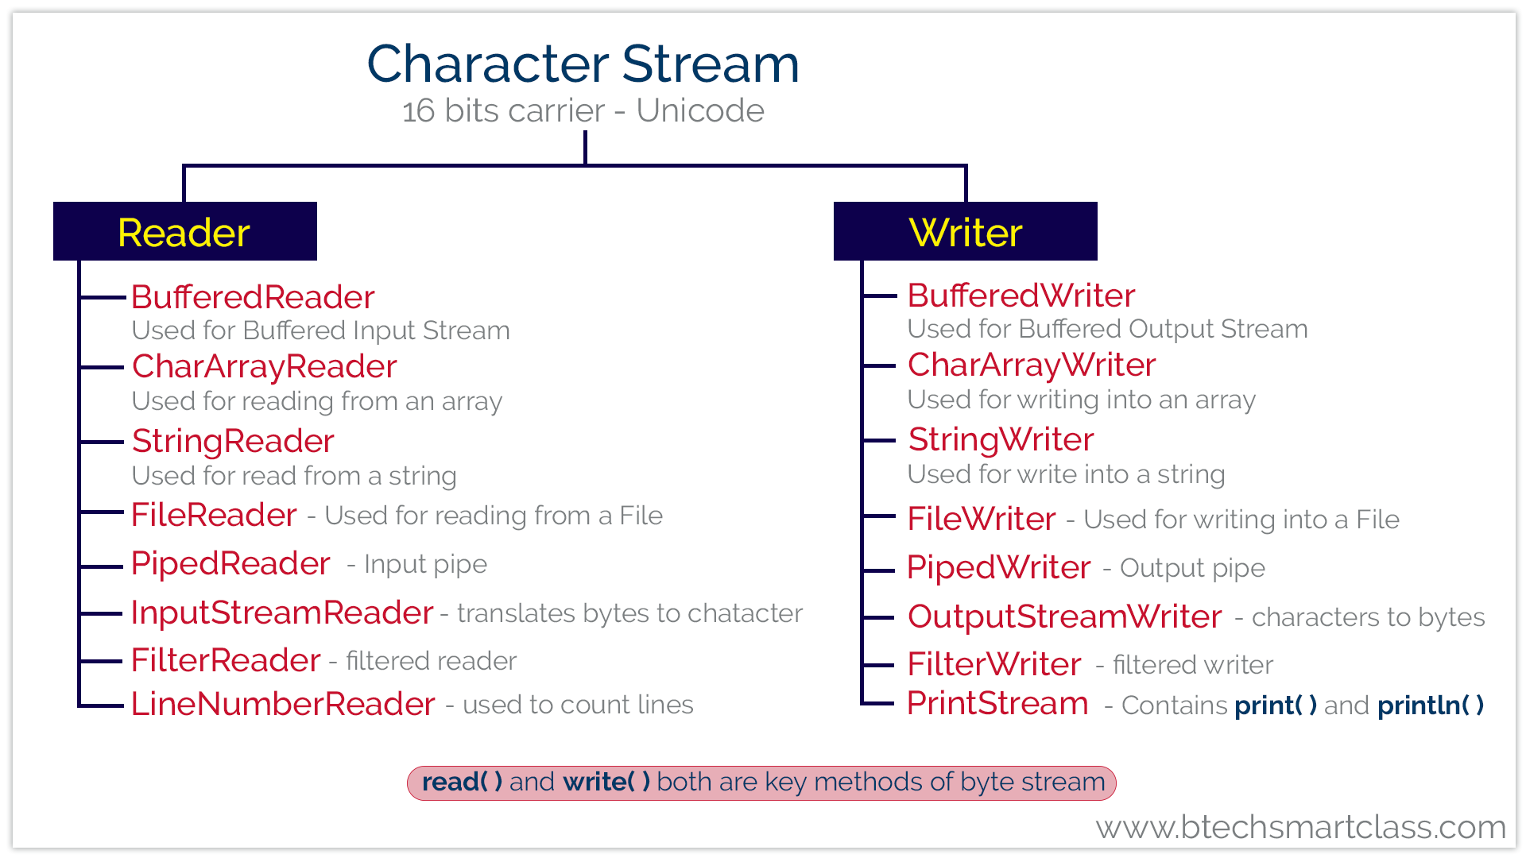

Resources in java:-

If your java code or predefined class java code uses system hardware those classes are called as resources

Serialization:-

Array:-

Group or collection of similar types of primitive values or reference values (objects) are called as array

The group of values can be accessed by a single array variable name along with the index number

Array Index starts from 0 to size-1

Array -> primitive values, Reference values

Pro:-

* Array elements or item can be access by sequentially and randomly

0 1 2 3 4 5 6

|  |  |  |  |  |  |  |
| --- | --- | --- | --- | --- | --- | --- |
| 56 | 34 | 89 | 45 | 9 | 80 | 44 |

Search 44

for(int i=0;i<array.length;i++){

if(array[i]==44){ //7 sec

}

}

Array[6]==44 – 1sec

Cons:-

* Once array size is fixed then you cannot increase or decrease further
  + int[] marks=new int[5];// static size
* Insertion and deletion of element involves movement of physical data back and forth.

Collections:-

Collection is a collection of or group of similar type of reference values (Object) that can be accessed by single variable name are called as collection.

Collections are dynamic in size. Size grow and shrink

Collection is a framework in java. Set of interfaces abstract classes and concrete classes

Each collection classes are backed by one data structure algorithm

All the collection are available java.util package

Collection stores a group object.

1. predefined object

2. userdefined object

Datastructures -> array, linkedlist, stack, queue, hashing technique, tree and graph

Collection Class Hierarchy:-

===========================

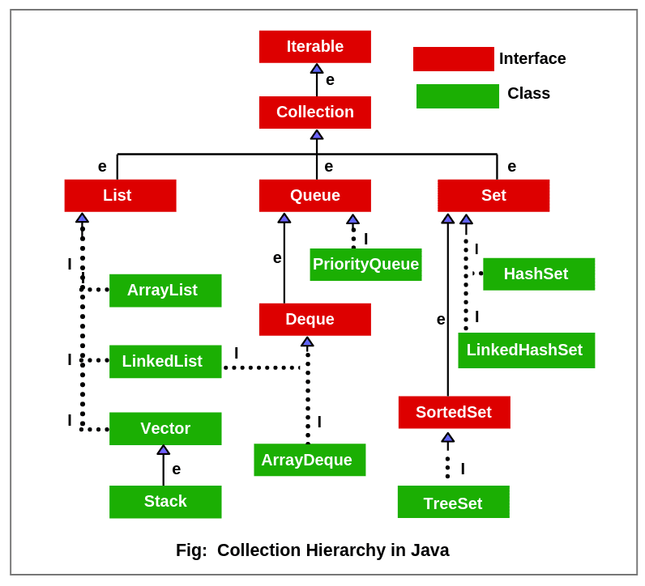

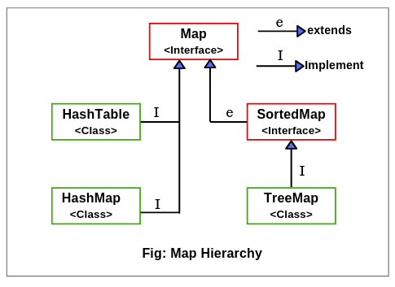

How to you decide which collection class you need to use

1. Ordered or unordered

2. Duplicate

3. null

Collection – store group of objects

String s=new String();

s -> predefined string class object

Employee e=new Employee();

e -> user defined Employee class object

ArrayList list=new ArrayList();

-> array[16*2] – index – random access

List.add(34);

LinkedList -> Doubly LinkedList datastructure

|  |  |
| --- | --- |
| ArrayList | Linkedlist |
| Array ds | Doubly linkedlist ds |
| Random access | Sequential access |
| Insertion deletion is very difficult | Insertion and Deletion is easy by rearranging the pointers |

Vector:-

HashSet :-

Unorederd

Not Accepting the duplicate (unique)

It will accept one null value

LinkedHashSet:-

Ordered

Not accepting the duplicate (unique)

It will accept one null value

TreeSet:-

Sorted Order (unorder)

Not accepting the duplicate (unique)

It will not accept even one null value

|  |  |
| --- | --- |
| Set Interface | Map Interface |
| HashTable,HashSet, LinkedHashSet, TreeSet | HashTable,HashMap,LinkedHashMap,TreeMap |
| HashSet – Unordered, no duplicate, one null value | HashMap – Unordered key, no duplicate key, one null key |
| LinkedHashSet – Ordered, no duplicate, one null value | LinkedHashMap – Ordered key, no duplicate key, one null key |
| TreeSet – Sorted in Ascending order, no duplicate, not even a single null accepted | TreeMap – Sorted in Ascending order key, no duplicate key, not even a single null key accepted |

List -> ArrayList, LinkedList, Vector -> Collections.sort()

Comparable –

Comparator –

HashSet,LinkedHashSet,TreeSet

Multitasking:-

More than one task executed in a computer is called as multitasking

Multitasking can achieved by 2 ways:-

1. Process based multitasking

Heavyweight

Context switch between the processes very costly

2. Thread based multitasking

Lightweight

Context switch is easy

Thread -> executable in a cpu or processor

In java you can create a thread

Two ways you can create a thread

1. By extending a thread class

2. By Implementing a Runnable interface

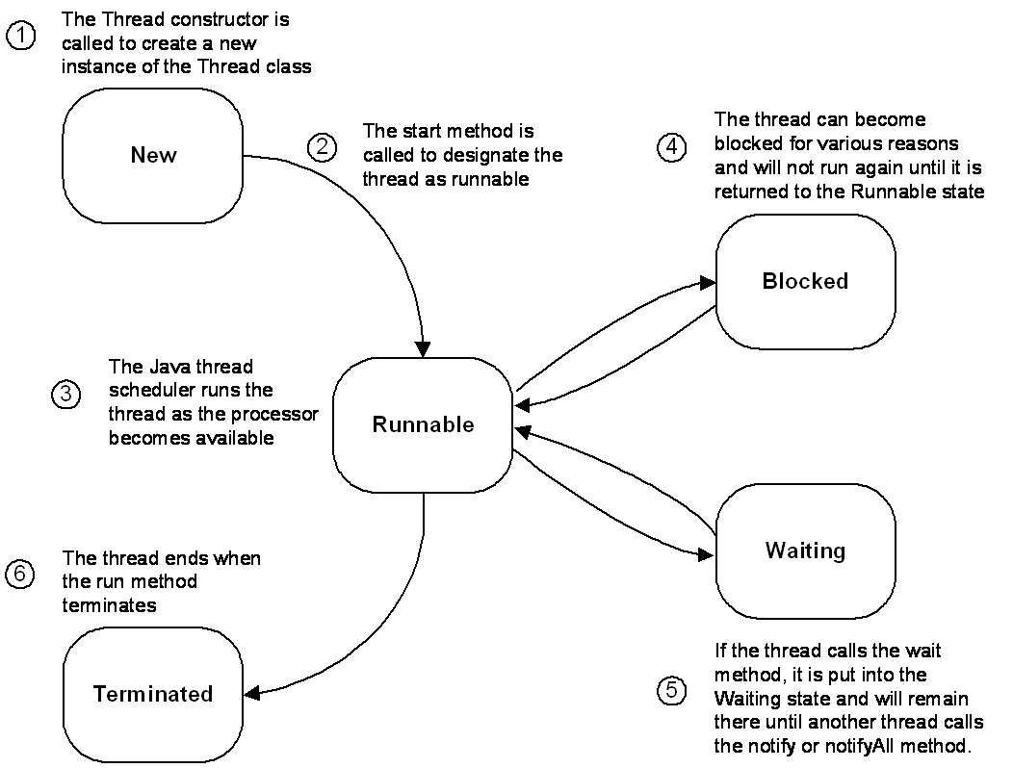

Thread deadlock:-

All the threads are waiting for the same resource

Synchronized – can control the deadlock

Jdk 1.8:-

=======

Functional interface

Default method

Static method

Lamda expression

forEach

Stream API

LocalDate Loclatime

Functional Interface:-

* If an interface has exactly one abstract method that interface can call it as functional interface
* You can have one or more implemented method inside then functional interface
* From jdk 1.8 inside the interface you can write instance method with the default keyword and static method static keyword

1. User defined functional interface

2. Predefined functional interface

Runnable

Comparable

Comparator

Predicate

Function

Consumer

Lamda Expression rules:-

1. lamda expression does not take access modifier and nonaccess modifier

2. lamda expression does not take return type

3. lamda expression does not take method name

4. lamda expression after the arg need to place an arrow operator (->)

5. lamda expression implementation has only one statement can remove curly braces

5. lamda expression implementation has only one statement that too it is a return statement you can remove return keyword

Lamda expression:-

5. In the lamda expression has an arguments you can the data type of the argument

It provides a clear and concise way to represent one method

public void add(){

s.o.p(“welcome”);

}

Equivalent Lamda Expression:-

----------------------------------

()->s.o.p(“welcome”); // lamda expression

**************************************

public void add(int a,int b){

s.o.p(“welcome”);

}

Equivalent Lamda Expression:-

----------------------------------

(a,b)-> s.o.p(“welcome”);

public void add(){

return 56;

}

Equivalent Lamda Expression:-

----------------------------------

()-> 56;

public void add(int a,int b){

return a+b;

}

Equivalent Lamda Expression:-

----------------------------------

(a,b)->a+b;

Lamda expression can be written with the help of only **functional interface**

Method Reference:-

It is shorthand for lamda expression

Instance method – Method reference

Static method – Method Reference

Constructor – method Reference

IO stream – input and output

Stream API:- process, managing, manipulating the group of objects

Introduced in Java 8, the Stream API is used to process collections of objects. A stream is a sequence of objects that supports various methods, which can be pipelined to produce the desired result.

The features of Java stream are –

* A stream is not a data structure instead it takes input from the Collections, Arrays or I/O channels.
* Streams don’t change the original data structure, they only provide the result as per the pipelined methods.
* Each intermediate operation is lazily executed and returns a stream as a result, hence various intermediate operations can be pipelined. Terminal operations mark the end of the stream and return the result.

Collections VS Stream APIEnums:-

Enumerations serve the purpose of representing a group of named constants in a programming language

Enums are used when we know all possible values at **compile time**

In Java (from 1.5), enums are represented using **enum** data type

In Java enums, we can also add variables, methods and constructors to it.

The main objective of enum is to define our own data types(Enumerated Data Types).

**Declaration of enum in java :**

* Enum declaration can be done outside a Class or inside a Class but not inside a Method.

**Important points of enum :**

* Every enum is internally implemented by using Class.

enum Color{

RED, BLUE, GREEN;

}

/* internally above enum Color is converted to

class Color

{

public static final Color RED = new Color();

public static final Color BLUE = new Color();

public static final Color GREEN = new Color();

}*/

* Every enum constant represents an **object** of type enum.
* enum type can be passed as an argument to **switch** statement.
* Every enum constant is always implicitly **public static final**. Since it is **static**, we can access it by using the enum Name. Since it is **final**, we can’t create child enums.

**Enum and Inheritance :**

* All enums implicitly extend **java.lang.Enum class**. As a class can only extend **one** parent in Java, so an enum cannot extend anything else.
* **toString() method** is overridden in **java.lang.Enum class**, which returns enum constant name.
* enum can implement many interfaces.

**values(), ordinal() and valueOf() methods :**

* These methods are present inside **java.lang.Enum**.
* **values() method** can be used to return all values present inside enum.
* Order is important in enums.By using **ordinal() method**, each enum constant index can be found, just like array index.
* **valueOf() method** returns the enum constant of the specified string value, if exists.

**enum and constructor :**

* enum can contain a constructor and it is executed separately for each enum constant at the time of enum class loading.
* We can’t create enum objects explicitly and hence we can’t invoke enum constructor directly.

**enum and methods :**

* enum can contain both **concrete** methods and **abstract** methods. If an enum class has an abstract method, then each instance of the enum class must implement it
  1. Writing Code That Explicitly Makes Objects Eligible for Garbage Collection

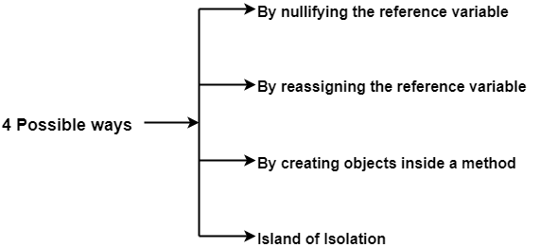

**Software testing**

**Testing -> we going to check piece of code is working as we expected**

**QA -> Quality Assurance**

**Unit Testing**

Unit testing is the process of checking small pieces of code to ensure that the individual parts of a program work properly on their own, speeding up testing strategies and reducing wasted tests.

### Integration Testing

Integration testing ensures that an entire, integrated system meets a set of requirements. It is performed in an integrated hardware and software environment to ensure that the entire system functions properly.

### End to End Testing

End to end testing is a technique that tests the application’s workflow from beginning to end to make sure everything functions as expected.

### Functional Testing

Functional testing checks an application, website, or system to ensure it’s doing exactly what it’s supposed to be doing.

### Non Functional Testing

Nonfunctional testing verifies the readiness of a system according to nonfunctional parameters (performance, accessibility, UX, etc.)  Which are never addressed by functional testing.

### Performance Testing

Performance testing examines the speed, stability, reliability, scalability, and resource usage of a software application under a specified workload.

### Regression Testing

Regression testing is performed to determine if code modifications break an application or consume resources.

Unit testing in java

Junit – Testing Framework

**Unit test-> manual, automatic ->**

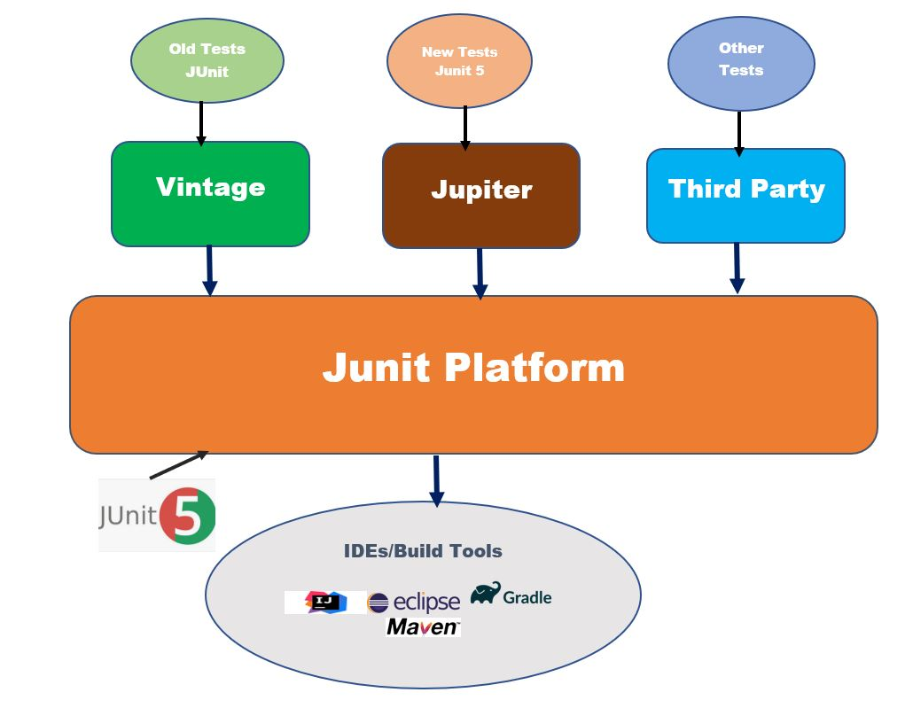

**Junit:**

**How to write a test case method**

**1. test case method must be public**

**2. test case method doesn’t return anything**

**3. test case method doesnot any argument**

**4. test case method name should with the keyword test**

**5. all the test case method annotated with @java**

**Test case**

**It is a java function. That has a rule. On top of the method @Test**

**@Test**

**Public void testFunctionName(){**

**}**

**Lifecycle method junit5:-**

**@BeforeAll -> In the test class before any test case gets execute before all works**

**@AfterAll -> In the test class after executing all the testcase after all works**

**@BeforeEach-> it will execute before each test case execution**

**@AfterEach -> it will execute after each and every test case executed**

**Note:-**

**Junit 5 needs jdk1.8**

I need junit5 dependencies

**Junit 5 Assumption:-**

**ASSUMPTION BASICALLY MEANS “DON’T RUN THIS TEST IF THESE CONDITIONS DON’T APPLY”.**

**Assumptions** class provides following overloaded methods.

1. Assumptions.assumeTrue() –  If the  condition is true, then run the test, else aborting the test.
2. Assumptions.false() –  If the  condition is false, then run the test, else aborting the test.
3. Assumptions.assumingThat() –   is much more flexible, If condition is true then executes, else do not abort test continue rest of code in test.

**Example**

public class JUnit5_Assumptions_Test {

// assumeTrue() -> Run only if environment is DEV

@Test

void testOnlyOnDevEnvironment() {

assumeTrue("DEV".equals(System.getenv("ENV_SETUP")));

User user = new User(1, "Peter", "peterm@email.com");

UserService.saveOrUpdate(user);

assertTrue(UserService.users.get(new Long(1)) == user);

}

// assumeFalse() -> Run only if environment is not PROD

@Test

void testOnlyIfNotOnProdEnvironment() {

assumeFalse("PROD".equals(System.getenv("ENV_SETUP")));

User user = new User(1, "Peter", "peterm@email.com");

UserService.saveOrUpdate(user);

assertTrue(UserService.users.get(new Long(1)) == user);

}

// assumeTrue() -> Run only if environment is DEV, if not display message

@Test

void testOnlyOnDeveloperWorkstation() {

assumeTrue("DEV".equals(System.getenv("ENV_SETUP")),

() -> "Aborting test: not on developer workstation");

// not perform if assuption fail

User user = new User(1, "Peter", "peterm1@email.com");

UserService.saveOrUpdate(user);

assertTrue(UserService.users.get(new Long(1)) == user);

}

// assumeThat()

@Test

void testInAllEnvironments() {

assumingThat("DEV".equals(System.getenv("ENV_SETUP")),

() -> {

// perform these assertions only on the DEV server

UserService.saveOrUpdate(new User(1, "Peter", "peterm@email.com"));

});

// perform these assertions in all environments

User user = new User(1, "Peter", "peterm1@email.com");

UserService.saveOrUpdate(user);

assertTrue(UserService.users.get(new Long(1)) == user);

}

}

## **What Is a**DynamicTest**?**

The standard tests annotated with @Test annotation are static tests which are fully specified at the compile time. **A DynamicTest is a test generated during runtime**. These tests are generated by a factory method annotated with the @TestFactory annotation.

A @TestFactory method must return a Stream, Collection, Iterable, or Iterator of DynamicTest instances. Returning anything else will result in a JUnitException since the invalid return types cannot be detected at compile time. Apart from this, a @TestFactory method cannot be static or private.

The DynamicTests are executed differently than the standard @Tests and do not support lifecycle callbacks. Meaning, the **@BeforeEach and the @AfterEach methods will not be called for the DynamicTests**.

@TestFactory Collection<DynamicTest> **dynamicTestsWithCollection**() { **return** Arrays.asList( DynamicTest.dynamicTest("Add test", () -> assertEquals(2, Math.addExact(1, 1))), DynamicTest.dynamicTest("Multiply Test", () -> assertEquals(4, Math.multiplyExact(2, 2)))); }

The @TestFactory method tells JUnit that this is a factory for creating dynamic tests.

**Each of the DynamicTest consists of two parts, the name of the test or the display name, and an Executable**.

@TestFactory Iterable<DynamicTest> **dynamicTestsWithIterable**() { **return** Arrays.asList( DynamicTest.dynamicTest("Add test", () -> assertEquals(2, Math.addExact(1, 1))), DynamicTest.dynamicTest("Multiply Test", () -> assertEquals(4, Math.multiplyExact(2, 2)))); }

@TestFactory Iterator<DynamicTest> **dynamicTestsWithIterator**() { **return** Arrays.asList( DynamicTest.dynamicTest("Add test", () -> assertEquals(2, Math.addExact(1, 1))), DynamicTest.dynamicTest("Multiply Test", () -> assertEquals(4, Math.multiplyExact(2, 2)))) .iterator(); }

@TestFactory Stream<DynamicTest> **dynamicTestsFromIntStream**() { **return** IntStream.iterate(0, n -> n + 2).limit(10) .mapToObj(n -> DynamicTest.dynamicTest("test" + n, () -> assertTrue(n % 2 == 0))); }

Parameterized Test

parameterized tests. This feature enables us to **execute a single test method multiple times with different parameters.**

In order to use JUnit 5 parameterized tests, we need to import the [junit-jupiter-params](https://search.maven.org/search?q=a:junit-jupiter-params%20AND%20g:org.junit.jupiter) artifact from JUnit Platform. That means, when using Maven, we'll add the following to our pom.xml:

<**dependency**>

<**groupId**>org.junit.jupiter</**groupId**>

<**artifactId**>junit-jupiter-params</**artifactId**>

<**version**>5.7.0</**version**>

<**scope**>test</**scope**>

</**dependency**>

**public** **class** **Numbers**

{

**public** **static** **boolean** **isOdd**(**int** number)

{

**return** number % 2 != 0;

}

}

@ParameterizedTest

@ValueSource(int s = {1, 3, 5, -3, 15, Integer.MAX_VALUE}) // six numbers **void** **isOdd_ShouldReturnTrueForOddNumbers**(**int** number)

{

assertTrue(Numbers.isOdd(number));

}

BDD:-

Behavioral Driven Development

Requirement -> code (logic) –> test (test class-> test case)

TDD:-

Test Driven Development

Requirement -> test (test class- test cases) -> code (implementation)

## What is Test Driven Development (TDD)?

Test driven development is an iterative development process. In TDD, developers write a test before they write just enough production code to fulfill that test and the subsequent refactoring. Developers use the specifications and first write test describing how the code should behave. It is a rapid cycle of testing, coding, and refactoring.

TDD means letting your tests drive your development (and your design). You can do that with unit tests, functional tests, and acceptance tests.

## What are the advantages of TDD?

### Code Quality

### Application Quality

### Increases Developers’ Productivity

### Higher Test Coverage

### Living Documentation

## Steps of Test Driven Development

### Step 1: Create a test and make it fail (Red)

### Step 2: Make the test pass by any means necessary (Green)

## **1) Connect to PostgreSQL database**

psql -d database -U user -W

## **2) Switch connection to a new database**

\c dbname username

## **3) List available databases**

\l list the database

## **Listing databases in PostgreSQL using SELECT statement**

SELECT datname FROM pg_database;

## **4) List available tables**

\dt

## **5) Describe a table**

\d table_name

## **6) List available schema**

\dn

## **7) List available functions**

\df

## **8) List available views**

\dv

## **9) List users and their roles**

\du

SELECT current_schema();

Postgressql

1. Create a database

Syntax:

CREATE DATABASE database;

2. Alter a database

ALTER DATABASE database;

3. Rename the database

ALTER DATABASE name RENAME TO new_name

4. List available databases

\l

5. Switch between the database

\c databasename username

6. delete a database

DROP DATABASE databasename;

Managing the table structure:-

1. create a table

2. Alter the table – add a column, remove a column, rename the column

3. drop the table

4. rename the table

5. view the table structure

1. Create a table

CREATE TABLE tablename(column1name datatype(size),

Column2name datatype (size), column3name datatype (size),

……);

CREATE TABLE tablename(column1name datatype(size) CONSTRAINT constraintname constrainttype,

Column2name datatype (size) CONSTRAINT constraintname constrainttype, column3name datatype (size) CONSTRAINT constraintname constrainttype,

……);

2. To view table structure or definition

\d tablename

3. Alter the table – Add a column

ALTER TABLE tablename ADD COLUMN columnname datatype(size)

4. Alter the table – Drop a column

ALTER TABLE tablename DROP COLUMN columnname;

5. Alter the table – Rename the columnname

ALTER TABLE tablename RENAME COLUMN oldcolumnname TO newcolumnname;

6. Rename the table

ALTER TABLE tablename RENAME TO newtablename;

7. delete a table

DROP TABLE tablename;

Psql(shell)

Rajesh ----------- postgresql

(commands -> SQL)

SQL (Structured Query Language) -🡪 RDBMS(mysql, oracle)

1. DDL(Data Definition Language)- structure

1.1 CREATE TABLE

1.2 ALTER TABLE

1.3 RENAME TABLE

1.4 DESCRIPTION TABLE

1.5 DROP TABLE

2. DML (Data Manipulation Language) (ROW DATA)

2.1 INSERT

INSERT INTO tablename VALUES(value1,value2,value3,..);

INSERT INTO tablename (columnname1,columnname2,columnname3,…)values(value1,value2,value3,..);

2.2 SELECT -> read and show the table and the data

SELECT * FROM tablename;

SELECT * FROM tablename WHERE condition;

Where -> filter the row

Select -> filters the column from the selected row

Select *

2.3 UPDATE

UPDATE tablename SET columnname=newvalue,

columnname=newvalue, columnname=newvalue,….

Where condition;

2.4 DELETE

DELETE FROM tablename WHERE condition;

3. DCL (Data Control Language)

3.1 GRANT

3.2 REVOKE

4. TCL (Transaction Control Language)

4.1 COMMIT

4.2 ROLLBACK

4.3 SAVEPOINT

Postgres Datatypes:-

Integer input -> smallint int bigint

Decimal input -> decimal, numeric, real, float

Character input ->

|  |  |
| --- | --- |
| character varying(***n***), varchar(***n***) | variable-length with limit |
| character(***n***), char(***n***) | fixed-length, blank padded |
| Text | variable unlimited length |

Date input -> date

Time input -> time

Date time input -> timestamp

SQL Clauses:-

Clause – It is a filter

Clauses – will occur on the sql commands

Schema | Name | Type | Owner

--------+-------------+-------+----------

public | bank | table | postgres

public | bank1 | table | postgres

public | employee | table | postgres

public | employee123 | table | postgres

public | loan | table | postgres

public | student | table | postgres

**From clause** – A database has many table. Filter and takes one table

Select * from employee;

**Select clause** – from the selected table. Filter the columns

students=# select * from employee;

id | name | phone

-----+--------+-------

100 | rajesh | 88745

101 | kumar | 67888

102 | tanuj | 88745

| fdd | 88745

(4 rows)

**Where clause** – a selected table and columns return one or more rows. The rows are filtered based on condition given in the where clause.

Where condition -> filter

**Limit Clause** -> it is going to limit no of records return by the where clause

**Distinct clause** used filter the duplicate value from the column

**Order By Clause ->** sort the resultset data

**Group By Clause ->** group the record or row based on one column

**Having Clause ->** always comes with group by clause

It is similar where clause

Where condition ->it filters the row from the table based on condition

Having condition -> it filters the row from the grouped by resultset based on condition

**SQL Functions-> Aggregate Function** select clause can call the function

**Min(columnaname)**

**Max(columname)**

**Sum(columname)**

**Avg(columnname)**

Count(columnname)

SQL Wild cards:-

* + If it varchar, char, text datatype column values partially can use wild cards search
  + Wild characters %_
    - % - any character
    - _ - single character
    - * - all
  + Wildcards can be used in the where clause

Ex:-

S% -> name starts charcter S followed by any no character

%V% ->

ResultSet -> After the select query was executed. The select query results memory pointed by resultset. Limit clause from resultset

Constraints:- it is conditions applied on a column

Datatype:-

Restrict the value to be given in the column

Size:-

Restrict the length of the data

|  |  |  |  |  |
| --- | --- | --- | --- | --- |
| Studentid  Integer(3) | Name  Varchar(10) | Cgpa  float | City  Varchar(8) | Phone  Bigint |
| 213 | Rajesh | 7.8 | Chennai | 568688 |
| 678 | Vishal | 8.8 | hyb | 678788 |
|  | Mani | 5.6 | chennai | 787668 |
| 213 | Rajesh | 7.8 | Chennai | 568688 |

Constraint can be set in the column

1. NULL -> that column null value

2. NOT NULL -> That column will not accept null value

It will accept duplicate value

3. UNIQUE -> that column all value must be different (doesnot accepts a duplicate)

It will accept a null value

4. PRIMARY KEY -> unique + not null

-> That column all values must be unique,

Doesnot accepts a null value

5. CHECK -> That column value should satisfy check condition

6. FOREIGN KEY ->

Joins:-

When you want to fetch a data from more than one table then we need to joins.

Both the table should have a common column name or common values

Theta Style:-

Select columnnames from table1,table2 where table1.columnanme=table2.columnname;

Ansi Style:-

Select columnnames from table1 join table2 on table1.columnanme=table2.columnname;

Cross join -> row are multiplied, columns are added

It will generate more data

Inner join -> it is going to return which are matching the

join condition

Equi Join:-

Select columnnames from table1 inner join table2 on table1.columnanme=table2.columnname;

Non Equi Join:-

Select columnnames from table1 inner join table2 on table1.columnanme<=table2.columnname;

natural join

Select columnnames from table1 natural join table2;

Natural Join -> also a type of inner join but natural join does not takes explicit join condition. Inner join takes explicit join condition

Natural join will not take an explicit join condition. Internally natural join will take both table common column name and it will create join condition implicitly

If both the table doesnot have a common column name natural join will yields the cross join results

Outer join -> it is going to return a results join condition both matching and non-matching record

Left outer join

Right outer join

Full outer join

Self join -> If we write join query using single table it is self join

Alias Name -> columnname , tablename

Views in SQL:-

Views are virtual table or logical table

View can be created from one or more physical DB table

Syntax:

CREATE VIEW viewname AS SELECT query;

In Memory – view structure memory get’s created

For Data in view memory will not create. Data is refered from the physical table on which view is got created

We can perform DML commands on any view

When you perform insert,update,delete changes will effect on view and also underlying physical table on which view is got created data affected

Adv:-

Security

Restriction on the columns

Set Operation:-

All SELECT statements that are used with a SET operator must select the same number of columns. The columns used in the display are obtained from the first query.

Set Operator:-

UNION

UNION ALL

INTERSECTION

DIFFERENCE

Rule set operator

Both the table need to have same no of columns and name

Both the table column should have a same data type

JDBC(Java Database Connectivity):-

Why JDBC:-

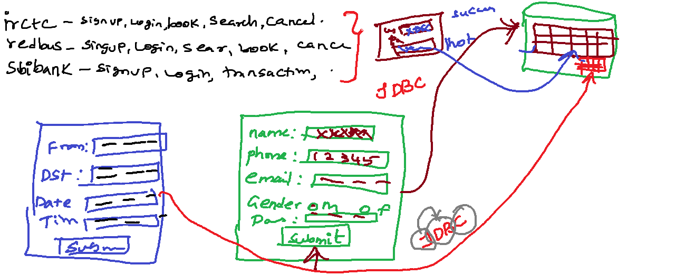

Jdbc api – java.sql, javax.sql – set of interfaces and abstract classes which has abstract unimplemented methods

Jdbc Driver -> has a set of classes that implements java.sql, javax.sql interface and abstract class abstract methods are implemented inside the classes of Jdbc Driver

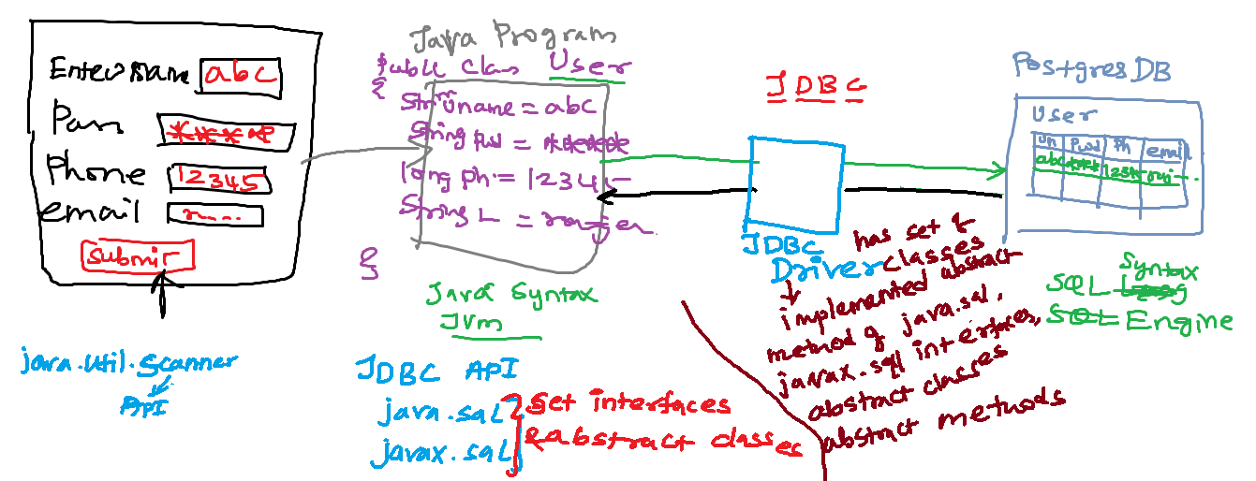

Java.sql

DriverManager(C)-> getConnection(url,uname,password)

Connection(I) ->

Statement createStatement() **throws** SQLException;

PreparedStatement prepareStatement(String sql)

**throws** SQLException;

CallableStatement prepareCall(String sql) **throws** SQLException;

DML:-

Insert,delete,update -> write operation->

Int executeUpdate(insert or delete or update query)

4 row inserted

Select -> read operation ->

ResultSet executeQuery(select query)

Select * from bank;

DML or DDL query

Boolean execute(DML or DDL query)

True – success

False - failure

Java JDBC API – JDBC Driver

Introduction JPA:-

* ORM – Object relational Mapping
* JPA ORM specification – it is a standard. what to do.
* JPA -> guidelines to perform ORM
* JPA – It’s a specification without an implementation
* JPA has set classes, interfaces, annotations helps you to persist in the ORM

JPA(specificaton)

|

|

|--------------------|

Hibernate (JPA provider) EclipseLink(JPA providers)

(Implementation of JPA (Implementation of JPA

Specification) Specification)

* [DataNucleus](https://en.wikipedia.org/wiki/DataNucleus)
* [EclipseLink](https://en.wikipedia.org/wiki/EclipseLink)
* [Hibernate](https://en.wikipedia.org/wiki/Hibernate_(Java))
* [OpenJPA](https://en.wikipedia.org/wiki/OpenJPA) (from version 2.2.0)

Java Project -> JPA specification – JPA API available javax.persistence package

JPA Implementation or provider -> Hibernate API – org.hibernate package

Jdbc Driver -> postgressql jdbc driver -> org.postgresql package

Maven, Gradle -> if I need third party dependency into my project

Project management tools like maven, gradle is going bring third party jars from the repositories

JPA Architecture:-

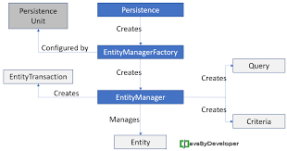

Step by Step to use JPA:-

Step 1. Create a maven project

Step 2. Add the following lines in the pom.xml

<properties>

<maven.compiler.source>1.8</maven.compiler.source>

<maven.compiler.target>1.8</maven.compiler.target>

</properties>

<dependencies>

<!-- https://mvnrepository.com/artifact/org.postgresql/postgresql -->

<dependency>

<groupId>org.postgresql</groupId>

<artifactId>postgresql</artifactId>

<version>42.3.1</version>

</dependency>

<!-- https://mvnrepository.com/artifact/org.hibernate/hibernate-core -->

<dependency>

<groupId>org.hibernate</groupId>

<artifactId>hibernate-core</artifactId>

<version>5.6.1.Final</version>

</dependency>

</dependencies>

Step 3. Persistence.xml

Go to the src/main/java right click choose Folder

Give the Folder name as META-INF

Right click on the META-INF folder and choose File give the file name as persistence.xml

<persistence xmlns=*"http://java.sun.com/xml/ns/persistence"*

xmlns:xsi=*"http://www.w3.org/2001/XMLSchema-instance"*

xsi:schemaLocation=*"http://java.sun.com/xml/ns/persistence http://java.sun.com/xml/ns/persistence/persistence_2_0.xsd"*

version=*"2.0"*>

<persistence-unit name=*"customerunit"*>

<properties>

<property name=*"javax.persistence.jdbc.driver"* value=*"org.postgresql.Driver"*/>

<property name=*"javax.persistence.jdbc.url"* value=*"jdbc:postgresql://localhost:5432/postgres"*/>

<property name=*"javax.persistence.jdbc.user"* value=*"postgres"*/>

<property name=*"javax.persistence.jdbc.password"* value=*"root1234"*/>

<property name=*"hibernate.show_sql"* value=*"true"* />

<property name=*"hibernate.hbm2ddl.auto"* value=*"create"* />

</properties>

</persistence-unit>

</persistence>

Step 5: create an entity class that you would like persist

## Entities

An entity is a lightweight persistence domain object.

Typically, an entity represents a table in a relational database, and each entity instance corresponds to a row in that table.

The persistent state of an entity is represented through either persistent fields or persistent properties. These fields or properties use object/relational mapping annotations to map the entities and entity relationships to the relational data in the underlying data store.

If you want to make any class as a Entity class then you need to following rules

* The class must be annotated with the javax.persistence.Entity annotation.
* Persistent instance variables must be declared private, protected, or package-private and can be accessed directly only by the entity class’s methods. Clients must access the entity’s state through accessor or business methods.
* Add @Id annotation for the column as primary key for the entity class.
* The class must have a public or protected, no-argument constructor. The class may have other constructors.
* The class must not be declared final. Methods or persistent instance variables must not be declared final.
* If an entity instance is passed by value as a detached object, such as through a session bean’s remote business interface, the class must implement the Serializable interface.
* Entities may extend both entity and non-entity classes, and non-entity classes may extend entity classes.

Step 6. Create a main class with main method call the JPA persist method

Hbm2ddl:-

Create -> drop the existing table structure and creates a new table structure

Update

If table is not existing

* + - It will create a table and insert

If table is existing

* + - It will not create a table and it will do an insert

DML operations:-

Insert -> JPA method -> persist()

Select -> JPA method -> find()

Delete -> JPA method -> remove()

Update -> JPA method -> merge()

Entity Instance Lifecycle:-

Player -> entity class

Player p1=new Player(); ->Entity Instance

Player p2=new Player(); ->Entity Instance

Each entity instance has a lifecycle

That lifecycles are managed by EntityManager

The EntityManager managed by the programmer

The programmer can use JPA EntityManager methods to manage the lifecycle entity instance

Entity instances are in one of four states:

1. new or transient state

Player p1=new Player();

New entity instances have no persistent identity and are not yet associated with a persistence context.

2. managed or persistent state(inside persistent context)

Persist()

Managed entity instances have a persistent identity and are associated with a persistence context.

3. detached

Detach(), clear(), close()

Detached entity instances have a persistent identify and are not currently associated with a persistence context.

4. removed.

remove()

Removed entity instances have a persistent identity, are associated with a persistent context, and are scheduled for removal from the data store.

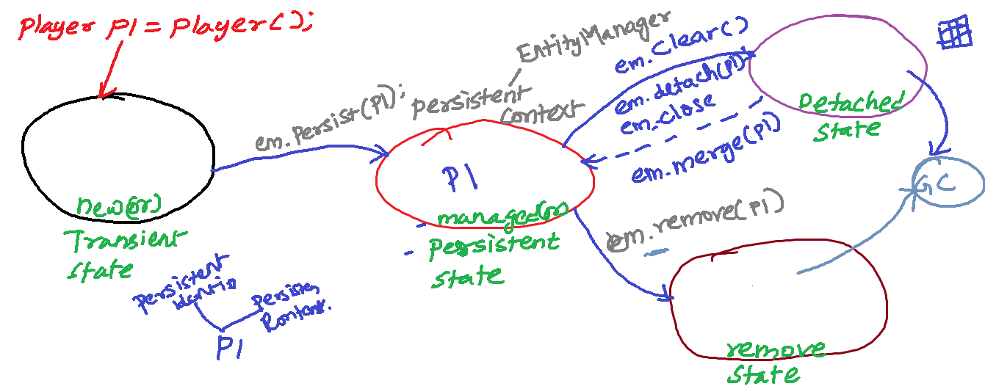

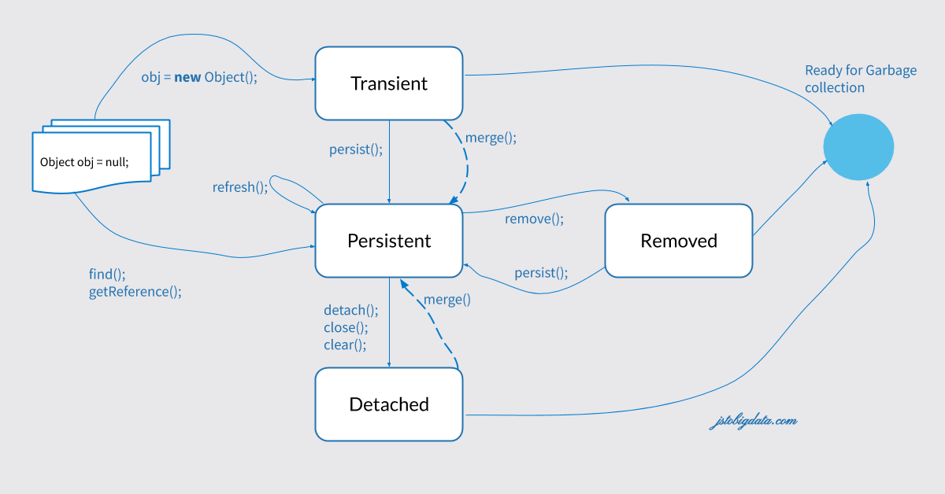

SQL ->

Structure Query Language -> sql table name and columnname

JPQL -> Java Persistence Query Language

It is similar to sql syntax but it works with Entity name and field names

@Entity

**public** **class** Trainee **implements** Serializable {

@Id

@GeneratedValue

**private** **int** traineeId;

**private** String traineeName;

**private** LocalDate dateOfJoining;

**private** String email;

**private** **long** phone;

}

JPQL> select traineeId,traineeName,dateOfJoining,email,phone from Trainee;

trainee Table:-

traineeid | dateofjoining | email | phone | traineename

-----------+---------------+----------------------+---------+-------------

4 | 1994-03-02 | rajesh.kit@gmail.com | 575546 | Rajesh

5 | 1967-07-13 | shivam@gmail.com | 5668675 | Shivam

7 | 2021-04-03 | rani@gmail.com | 555555 | Rani

(3 rows)

SQL> select traineeid,dateofjoining,email,phone,traineename from trainee;

Steps to create a JPQL Query:-

Step 1: call createQuery(“JPQL”) using EntityManager instance

Query q = em.createQuery("JPQL");

JPQL query we can use binding variable or positional parameter rather than giving value in the query

1. binding variable

:variablename

2. positional parameter

?position

Validation:-

* + Bean validator –> it’s a specification that contains classes and interfaces annotation
  + Validation implementation is not there in Bean validator
  + Hibernate validator -> it is bean validation provider. It contains the implementation bean validator

Step.1 add the following dependency in the pom.xml

<!-- Java bean validation API - Spec -->

<dependency>

<groupId>javax.validation</groupId>

<artifactId>validation-api</artifactId>

<version>2.0.1.Final</version>

</dependency>

<!-- Hibernate validator - Bean validation API Implementation -->

<dependency>

<groupId>org.hibernate</groupId>

<artifactId>hibernate-validator</artifactId>

<version>6.0.11.Final</version>

</dependency>

<!-- Verify validation annotations usage at compile time -->

<dependency>

<groupId>org.hibernate</groupId>

<artifactId>hibernate-validator-annotation-processor</artifactId>

<version>6.0.11.Final</version>

</dependency>

<!-- Unified Expression Language - Spec -->

<dependency>

<groupId>javax.el</groupId>

<artifactId>javax.el-api</artifactId>

<version>3.0.1-b06</version>

</dependency>

<!-- Unified Expression Language - Implementation -->

<dependency>

<groupId>org.glassfish.web</groupId>

<artifactId>javax.el</artifactId>

<version>2.2.6</version>

</dependency>

Critera API:-

Step.1 need to get CriteriaBuilder instance

CriteriaBuilder cb=em.getCriteriaBuilder();

Step.2

Spring Framework:-

Spring Framework is a Java platform

Spring handles the infrastructure so you can focus on your application.

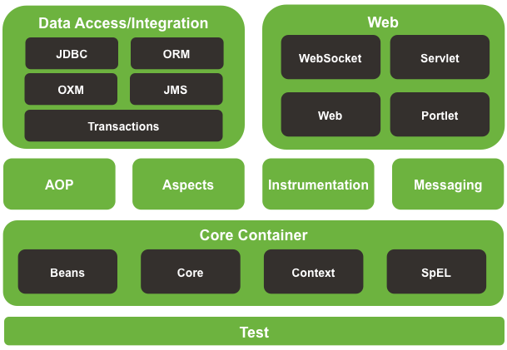

Core Container -> (core, context, bean, el) 🡪

1. Spring IOC container Or Inversion of control -> (beans -> pojo object)

Java Application

If the programmer creates, manages, destroy the java object -> control of the programmer

Eg:- Product p1=new Product();

Customer c1=new Customer();

Inversion of control:-

Rather than programmer creates an object and manages it. If spring framework creates and manages the object(bean) of your classes of application then it is called as **Inversion of Control**

1.1 BeanFactory Container (beans -> pojo object)

1.2 Application Context Container extends BeanFactory (beans -> pojo object)

2. Dependency Injection

2.1 Setter Based Injection

2.2 Constructor Based injection

What is a bean?

In Spring, the objects that form the backbone of your application and that are managed by the Spring IoC container are called beans.

A bean is an object that is instantiated, assembled, and otherwise managed by a Spring IoC container.

Spring Dependencies and configurations

The files which placed under src/main/java are the classpath

Shorthand handy representation of dependency injection

Namespace ‘p’ -> property ->setter based injection

Namespace ‘c’ -> constructor-> constructor based injection

Design Pattern:-

It is a solution to the problem

* + Creational Design Patterns
    - Factory Design Pattern
  + Behavioral Design Patterns
  + Structural Design Patterns

Bean Life Cycle:-

Bean started it will creating, instantiating, inject dependency, init, manage, destroy, close the container

1. init

2. destroy

HttpRequest

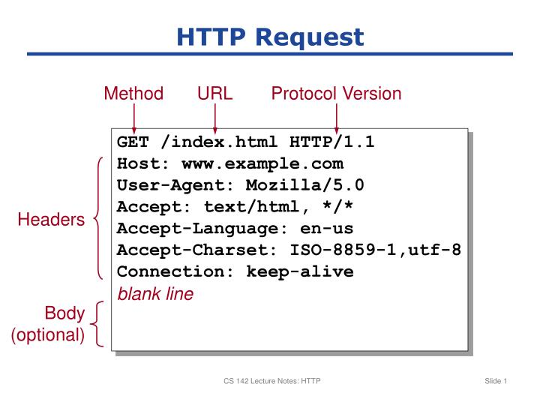

Java Application type:-

1. Console application – input / output in the console

Java -> jdk-> IDE perspective Java

2. Web application – client / server – input / output internet

Jdk – 1.8

J2EE – servlet api dependency

Web Server – Apache tomcat 10

IDE Perspective -> javaEE perspective

Java Web application:-

Jdk + J2EE(Servlet,jsp)javax.servlet-api + WebServer(Tomcat)

Spring java webapplication:-

Jdk + J2EE + WebServer(Tomcat) + spring Framework

(spring-web, spring-webmvc)

3. Mobile application

Tomcat

Plug and play

Installer

HTTP Response:-

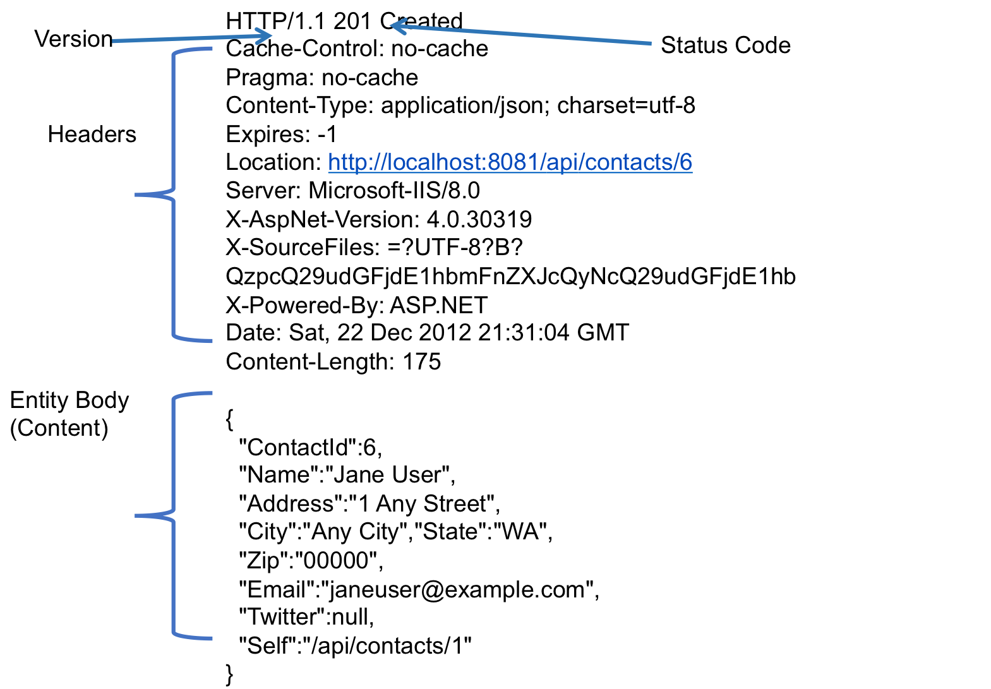

Model View Controller:-

Model – Data(POJO object)

View – html,jsp

Controller – servlet or @Controller

J2EE -> servlet , jsp

Java application:-

Java classes:-

Customer.java, player.java

Product.java

Servlet-> A java is a java class which extends HttpServlet. Servlet can capable handles the HttpRequests and HttpResponses

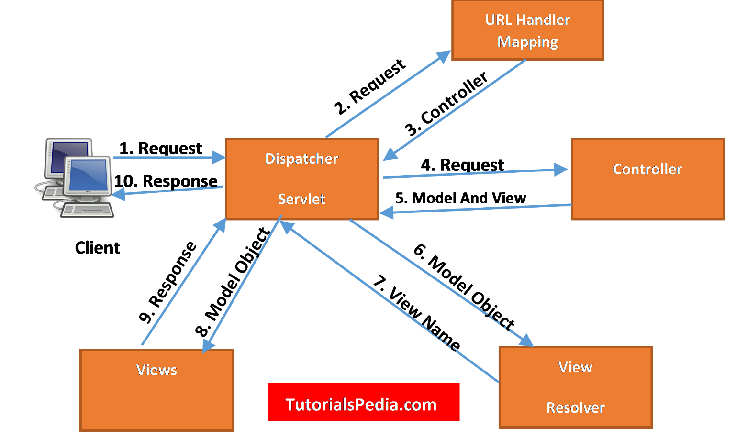

Creating Spring MVC project step by step:-

Step 1. create a maven project choose the archytype as org.apache.maven.webapp

Step 2. Change the jdk version

<properties>

<project.build.sourceEncoding>UTF- 8</project.build.sourceEncoding>

<maven.compiler.source>1.8</maven.compiler.source>

<maven.compiler.target>1.8</maven.compiler.target>

</properties>

Step 2. Add the following dependency in the pom.xml

Servlet, spring-web, spring-webmvc

<dependencies>

<!-- https://mvnrepository.com/artifact/javax.servlet/javax.servlet-api -->

<dependency>

<groupId>javax.servlet</groupId>

<artifactId>javax.servlet-api</artifactId>

<version>4.0.1</version>

<scope>provided</scope>

</dependency>

<!-- https://mvnrepository.com/artifact/org.springframework/spring-webmvc -->

<dependency>

<groupId>org.springframework</groupId>

<artifactId>spring-webmvc</artifactId>

<version>5.3.13</version>

</dependency>

<dependency>

<groupId>junit</groupId>

<artifactId>junit</artifactId>

<version>4.11</version>

<scope>test</scope>

</dependency>

</dependencies>

Step 3. Add the dispatcherservlet in web.xml file(WEB-INF/web.xml)

<!DOCTYPE web-app PUBLIC

"-//Sun Microsystems, Inc.//DTD Web Application 2.3//EN"

"http://java.sun.com/dtd/web-app_2_3.dtd" >

<web-app>

<display-name>Archetype Created Web Application</display-name>

<servlet>

<servlet-name>capgemini</servlet-name>

<servlet-class>org.springframework.web.servlet.DispatcherServlet</servlet-class>

</servlet>

<servlet-mapping>

<servlet-name>capgemini</servlet-name>

<url-pattern>/</url-pattern>

</servlet-mapping>

</web-app>

Step 4. DispatcherServlet in web.xml configured previous step 3

DispatcherServlet will look for **bean configuration xml file** namely yourdispatcherservletname-servlet.xml under the

/WEB-INF/capgemini-servlet.xml

<?xml version=*"1.0"* encoding=*"UTF-8"*?>

<beans xmlns=*"http://www.springframework.org/schema/beans"*

xmlns:context=*"http://www.springframework.org/schema/context"*

xmlns:xsi=*"http://www.w3.org/2001/XMLSchema-instance"*

xsi:schemaLocation=*"*

*http://www.springframework.org/schema/beans*

*http://www.springframework.org/schema/beans/spring-beans.xsd*

*http://www.springframework.org/schema/context*

*http://www.springframework.org/schema/context/spring-context.xsd"*>

<context:annotation-config></context:annotation-config>

<context:component-scan base-package=*"controller"*></context:component-scan>

<bean class=*"org.springframework.web.servlet.view.InternalResourceViewResolver"*>

<property name=*"prefix"* value=*"/WEB-INF/"*></property>

<property name=*"suffix"* value=*".jsp"*></property>

</bean>

</beans>

GET /capgemini/submitsignup?username=Rajesh&usergender=Male&userpassword=dghfdfhdf&useremail=rajesh.kit%40gmail.com&userphone=457858&useraddress=jdafnjdnf%0D%0Asdfbsdfjn%0D%0Aasfnldjsfnlkn%0D%0Achennai&usercity=Chennai HTTP/1.1

Host: localhost:9090

Connection: keep-alive

Cache-Control: max-age=0

sec-ch-ua: "Google Chrome";v="93", " Not;A Brand";v="99", "Chromium";v="93" sec-ch-ua-mobile: ?1 sec-ch-ua-platform: "Android"

Upgrade-Insecure-Requests: 1 User-Agent: Mozilla/5.0 (Linux; Android 6.0; Nexus 5 Build/MRA58N) AppleWebKit/537.36 (KHTML, like Gecko) Chrome/93.0.4577.82 Mobile Safari/537.36

Accept:text/html,application/xhtml+xml,application/xml;q=0.9,image/avif,image/webp,image/apng,*/*;q=0.8,application/signed-exchange;v=b3;q=0.9

Sec-Fetch-Site: cross-site

Sec-Fetch-Mode: navigate

Sec-Fetch-User: ?1 Sec-Fetch-Dest: document

Referer: <http://localhost:9090/capgemini/signup>

Accept-Encoding: gzip, deflate, br Accept-Language: en-US,en;q=0.9,ta;q=0.8 Cookie: JSESSIONID=3D778BA9B20D321D88C4B4EC58DABD69

Step 1. Create a pojo class with private instance variable names that should matches name of the input control of the form

Step 2. Normal html form cannot handle UI to POJO object binding

**Alternate is spring forms**

**How to use spring forms**

On top of the jsp page form need to add spring form tag

<%@ taglib prefix="form" uri="http://www.springframework.org/tags/form"%>

Need to add spring form prefix before all html form tag and input controls tag

Ex:-

<form:form action=*"submitsignup"*>

Enter your name:<form:input type=*"text"* path=*"userName"*></form:input><br><br>

Select Gender: <form:input type=*"radio"* path=*"userGender"* value=*"Male"*></form:input>Male

<form:input type=*"radio"* name=*"userGender"* path=*"Female"*></form:input>Female<br><br>

Enter the password:<form:input type=*"password"* path=*"userPassword"*></form:input><br><br>

Enter your Email:<form:input type=*"email"* path=*"userEmail"*></form:input><br><br>

Enter your phone:<form:input type=*"number"* path=*"userPhone"*></form:input><br><br>

Enter your Address:<form:textarea rows=*"5"* cols=*"25"* path=*"userAddress"*></form:textarea><br><br>

Select your city:

<form:select path=*"userCity"*>

<option value=*"Chennai"*>Chennai</option>

<option value=*"Chennai"*>Mumbai</option>

<option value=*"Chennai"*>Kolkatta</option>

<option value=*"Chennai"*>Nellore</option>

<option value=*"Chennai"*>Metrocity</option>

</form:select><br><br>

<input type=*"submit"*>

<input type=*"reset"*>

</form:form>

Need to change all input control name attribute into path

As like in the previous code snippet example

Before the spring form renders create a pojo object and add that pojo object into the model

<form:form action=*"submitsignup"* **modelAttribute=*"u"*** >

</form:form>

Webserivces:-

Client server architecture

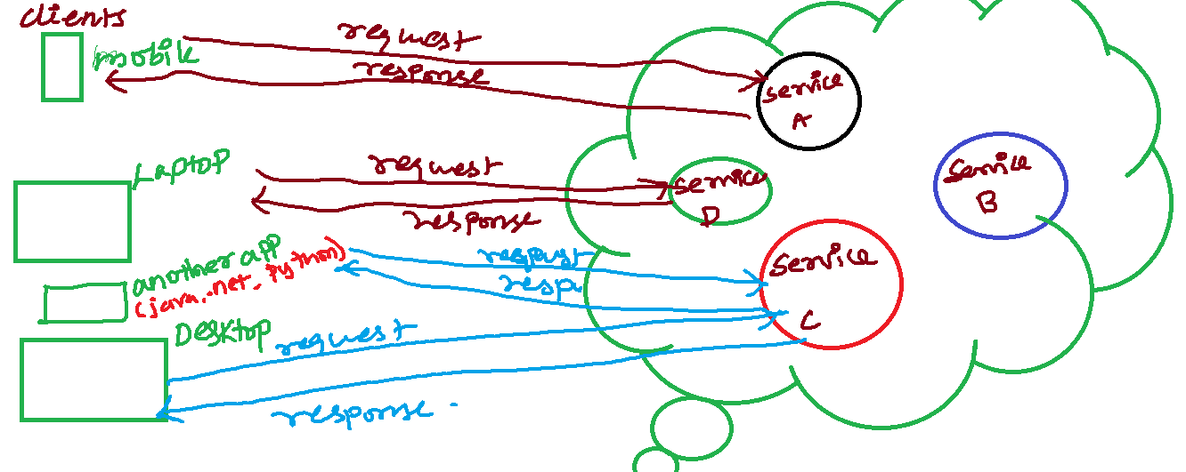

Ways to create webservice:-

1. SOAP webservice – Xml based webservice

2. Restfull Webservices

restfull architecture Standard, guideline, specification, rules then create an application it becomes an restfull webservice app.

REST -> REpresentation State Transfer

REST is an acronym for **RE**presentational **S**tate **T**ransfer and an architectural style for **distributed hypermedia systems**.

The six guiding principles or [constraints of the RESTful architecture](https://restfulapi.net/rest-architectural-constraints/) are:

### 

### 1.1. Uniform Interface

URI -> <http://pms.com/player>

Create -> <http://pms.com/player->> create a player resource

update -> <http://pms.com/player/playerId->> update a player resource

delete -> <http://pms.com/player/playerId->> delete a player resource

select -> <http://pms.com/player->> get all player resource

select -> <http://pms.com/player/playerId->> get a player resource

Rest API -------------------🡪 Http Protocol

Resource: methods:

========= =========

Create post method

Select get method

Update put method

Delete delete method

@Controller @RequestMapping -> spring mvc application

@Controller @RequestMapping @ResponseBody->

spring Restfull resource application

upto spring version 3.x.x

from spring 4.x.x till latest version 5.3.1

@RestController = @Controller + @ResponseBody

@RequestMapping

Spring Restfull application creation steps

Step 1. create a maven project choose the archytype as org.apache.maven.webapp

Step 2. Change the jdk version

<properties>

<project.build.sourceEncoding>UTF- 8</project.build.sourceEncoding>

<maven.compiler.source>1.8</maven.compiler.source>

<maven.compiler.target>1.8</maven.compiler.target>

</properties>

Step 2. Add the following dependency in the pom.xml

Servlet, spring-web, spring-webmvc

<dependencies>

<!-- https://mvnrepository.com/artifact/javax.servlet/javax.servlet-api -->

<dependency>

<groupId>javax.servlet</groupId>

<artifactId>javax.servlet-api</artifactId>

<version>4.0.1</version>

<scope>provided</scope>

</dependency>

<!-- https://mvnrepository.com/artifact/org.springframework/spring-webmvc -->

<dependency>

<groupId>org.springframework</groupId>

<artifactId>spring-webmvc</artifactId>

<version>5.3.13</version>

</dependency>

<dependency>

<groupId>junit</groupId>

<artifactId>junit</artifactId>

<version>4.11</version>

<scope>test</scope>

</dependency>

</dependencies>

Step 3. Add the dispatcherservlet in web.xml file(WEB-INF/web.xml)

<!DOCTYPE web-app PUBLIC

"-//Sun Microsystems, Inc.//DTD Web Application 2.3//EN"

"http://java.sun.com/dtd/web-app_2_3.dtd" >

<web-app>

<display-name>Archetype Created Web Application</display-name>

<servlet>

<servlet-name>capgemini</servlet-name>

<servlet-class>org.springframework.web.servlet.DispatcherServlet</servlet-class>

</servlet>

<servlet-mapping>

<servlet-name>capgemini</servlet-name>

<url-pattern>/</url-pattern>

</servlet-mapping>

</web-app>

Step 4. DispatcherServlet in web.xml configured previous step 3

DispatcherServlet will look for **bean configuration xml file** namely yourdispatcherservletname-servlet.xml under the

/WEB-INF/capgemini-servlet.xml

<?xml version=*"1.0"* encoding=*"UTF-8"*?>

<beans xmlns=*"http://www.springframework.org/schema/beans"*

xmlns:xsi=*"http://www.w3.org/2001/XMLSchema-instance"*

xmlns:mvc=*"http://www.springframework.org/schema/mvc"*

xmlns:context=*"http://www.springframework.org/schema/context"*

xsi:schemaLocation=*"http://www.springframework.org/schema/beans*

*http://www.springframework.org/schema/beans/spring-beans.xsd*

*http://www.springframework.org/schema/context*

*http://www.springframework.org/schema/context/spring-context.xsd*

*http://www.springframework.org/schema/mvc*

*http://www.springframework.org/schema/mvc/spring-mvc.xsd"*>

<context:annotation-config></context:annotation-config>

<context:component-scan base-package=*"com.demo.controller"*></context:component-scan>

<mvc:annotation-driven></mvc:annotation-driven>

</beans>

Step 5. If src/main/java is showing on a project goto project ->right click-> buildpath -> configure buildpath-> orderand export -> check all the checkboxes and applyclose

Step 6. Create a java a class inside the controller and annotated with @RestController

Step 7. Create a method inside the class and annotated with @RequestMapping annotation

Spring framework

RestTemplate -> used to make a http request on webservice

Post,get,put,delete etc

## **What Is Spring Boot?**

Spring Boot is basically an extension of the Spring framework, which eliminates the boilerplate configurations required for setting up a Spring application.

**It takes an opinionated view of the Spring platform, which paves the way for a faster and more efficient development ecosystem**.

Here are just a few of the features in Spring Boot:

* Opinionated ‘starter' dependencies to simplify the build and application configuration
* Embedded server to avoid complexity in application deployment
* Metrics, Health check, and externalized configuration
* Automatic config for Spring functionality – whenever possible

Spring Boot project can be created in 3 ways

1. Using spring.io initializer

2. sts IDE -> spring starter project

Spring-boot-starter-web

3. Spring boot cli

Spring Data JPA

JPA – Java Persistence Access

EntityManagerFactory emf=Persistence.*createEntityManagerFactory*("bankunit");

EntityManager em=emf.createEntityManager();

em.getTransaction().begin();

em.getTransaction().commit();

Spring Data JPA ->

The Spring Data JPA is mainly used to the development of the repository layer.

Boilerplate code in dao or repository layer can be avoided

**makes it possible to remove the DAO implementations entirely**.

Repository Pattern

Spring-boot-starter-jpa

**Repository(Marker interface)**

| extends

|

**CrudRepository(Interface)**

| save,saveAll,findById,existsById

| findAll,findAllById,count,delete | deleteById,deleteAll

| extends

**PagingAndSortRepository(Interface)**

|extends

| findAll(paging),findAll(sorting)

|

**JpaRepository(Interface)**

| findAll,findAllById,saveAll, flush,

| saveAndFlush, saveAllAndFlush,

|deleteAllInBatch, deleteAllByIdInBatch, getById(ID id)

Spring Data JPA:-

// Query Generation or Custom Query Generation

1. custom query generation by using method name

When we declare a method in the repository interface. Spring data JPA will take method and it will generate query on its own

2. custom query generation based on @Query

3. NamedQuery

Swagger:-

Restfull Application

* + An application follows rest architecture 6 rules of the architecture
  + Endpoints(API – Application program interface)
  + GET <http://localhost:9999/bms>/
  + GET <http://localhost:9999/bms/bank>
  + POST <http://localhost:9999/bms/bank>
  + GET <http://localhost:9999/bms/bank/123>
  + GET <http://localhost:9999/bms/bank/sbi>
  + GET <http://localhost:9999/bms/kashmir>
  + PUT <http://localhost:9999/bms/bank>
  + DELETE <http://localhost:9999/bms/bank>

**OpenAPI Specification** is an API description format for REST APIs. An OpenAPI file allows you to describe your entire API, including:

* Available endpoints (/users) and operations on each endpoint (GET /users, POST /users)
* Operation parameters Input and output for each operation
* Authentication methods
* Contact information, license, terms of use and other information.

Lombok Framework:-

* It helps us avoid the boilerplate code
* How to setup Lombok framework

1. Download the Lombok.jar

2. Give a double click on Lombok.jar

3. It will open a installer. You need to specify the location where sts IDE is there by selecting specify location button in the Lombok installer

4. Restart your sts IDE

* In order to use the Lombok on the project
  + - In the pom.xml need to add Lombok dependency

JPA(Java Persistence access) – ORM – pojo mappes to a db row

Spring - framework to loosely coupled distributed web application

Spring mvc application -> @Controller + @RequestMapping

Spring rest application->@Controller + @RequestMapping + @ResponseBody

Spring boot

Spring mvc application - @Controller + @RequestMapping

Spring boot rest application - @RestController + @RequestMapping

Spring data jpa

Repository layer or dao layer it avoids boilerplate ORM code

@Repository create an interface that should extends predefined interface like Repository, CrudRepository,PagingAndSorting,JpaRepository

Lombok

It used avoid the boilerplate code on model classes

Spring Data rest – It avoid the boilerplate code in the controller and service layer.

Spring boot rest application

Steps to create a Spring Boot Data Rest application

Step 1. Create a spring starter project

Step 2. Dependencies to be added for spring data rest project

RestRepository

Data Jpa

Lombok

Devtools

Postgres driver

Step 3. Create a model class use Lombok annotation jpa annotations

Step 4. Create a repository layer. Create an interface extends any of predefined repository interface

In-order to use Swagger steps to be followed

Step 4.1 Dependency spring-boot-starter-springfox

Swagger2

Swagger-ui

Swagger-data-rest

Step 4.2 create swaggerconfig class and annotate the class with @Configuration @EnableSwagger2 @Import()

(Leader 1):KRISHNAN P

Dipali Simdeo Khandait

Sharvari Dhanaji Patil

SHIVANISREE N

(Leader 2):Shantha Nayagi S

Aswani Kurlu

K N Ramya

KALLA PRIYANKA

(Leader 3):Janavi Kailas Patil

Kuntal Hemendra Girase

Payal Vijay Tembhurnikar

Shweta Avinash Thakare

(Leader 4):Sarika Verma

Shruti Vijay Akolkar

Pranali Gulab Daundkar

Adika Hiralal Kale

(Leader 5): Tanuja parwani

Santosh Bangari Devadig

Shivani Mishra

Sathivada Jaya vardhan

(Leader 6): Palash sahu

Sanket Bhaskar Shinde

Sanket Vishnu Mohalkar

Prasad Dilip Chaudhari

(Leader 7): Ankita Pandey

Tejasmayee Panda

Dikseeka J

Amrutha K P

AWS (Amazon Web services):- Service provider

Compute Service -> EC2-> AWS virtual Server

Windows server EC2 instance -> RDC -> RDP(portno)

Linux Server EC2 instance -> ssh client – putty

* + - Putty is a ssh client software
    - Download from the internet
    - Just an plug and play
    - Putty requires a private key of linux EC2 instance(.ppk)
    - Private key of the EC2 can be generated from key pair(.pem)
    - From the Key pair (private key + public key) extract private key by using another s/w putty key generator

Physical server -> existing in the world. It works as a server. We can touch and feel

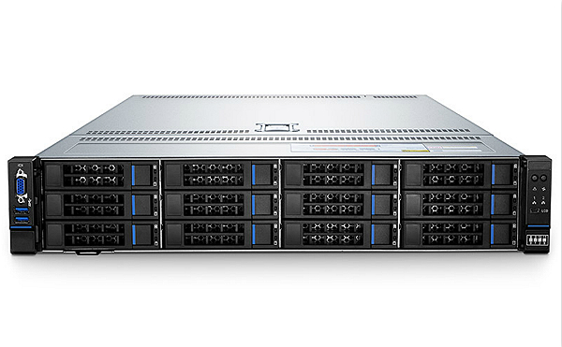

Disadvantages:-

* + - Cost is more
    - Infrastructure(Server Room, AC, Power supply, IT Team)
    - Scale In, Scale Out difficult

Virtual server-> existing in the world. It works as a server. We cannot touch and feel

**VM – virtual machine or virtual server or EC2 instance**

Virtualization only we can create **VM – virtual machine or virtual server or EC2 instance**

* + - Less cost
    - No infrastructure
    - Scale in, scale out it is easy

Virtualization can be achieved by **hypervisor**

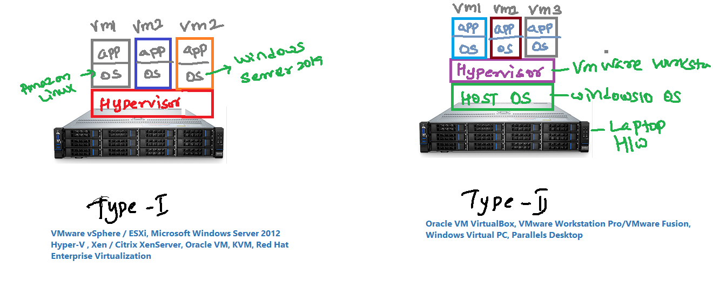

How hypervisor is working

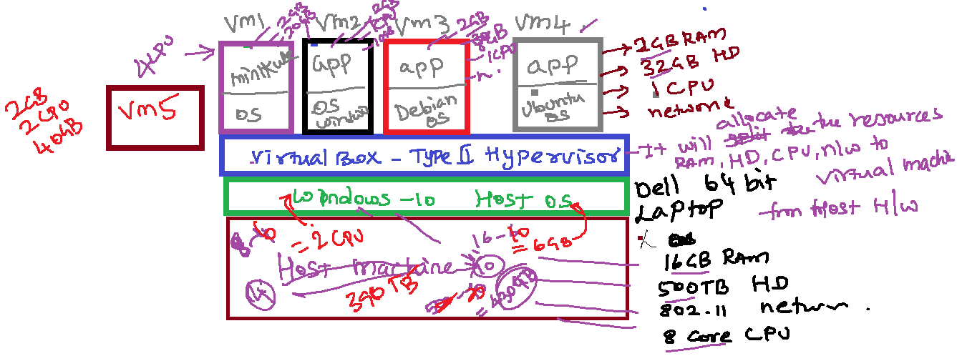

Step by Step to deploy the jar file into the Amazon Linux EC2:-

Step 1: STS -> bankmanagementsystem -> run as -> maven build -> maven goal as -> clean install

It will generate a jar file on project target folder

Project folder/target/bms.jar

Step 2: log into aws console -> create a EC2 amazon linux

Instance

Step 3: through ssh client putty take remote of amazon linux linux ec2 instance

Step 4: Install the java

Commands:-

Sudo su

sudo amazon-linux-extras install java-openjdk11

Step 5: Create s3 bucket in that bucket upload the (bms.)jar file

S3-> create bucket -> enter unique bucket name-> disable the checkbook **Block all public access -> create a bucket**

Once the bucket got created -> upload -> add files -> bms.jar into the s3 bucket

Step 6: Go into the remote of ec2 amazon linux instance

[root@ip-172-31-86-236 ec2-user]# aws configure

**[root@ip-172-31-86-236 ec2-user]# aws configure**

**AWS Access Key ID: [****************XW7Y]**

**AWS Secret Access Key: Th550cf5mPuW2QP8Yt6yX+DXEgnNk3ZP51Nduo4V**

**Default region name [None]: us-east-1**

**Default output format [None]: json**

**[root@ip-172-31-86-236 ec2-user]# aws s3 ls**

**It will list the bucket details**

Step 7: copy the bms.jar from s3 -> bankmanagement bucket to EC2 instance current directory

**[root@ip-172-31-86-236 ec2-user]# aws s3 cp s3://bankmanagement/bms.jar .**

**[root@ip-172-31-86-236 ec2-user]# ls -a**

**. .bash_history .bash_profile bms.jar**

**.. .bash_logout .bashrc .ssh**

Step 7: Run the bms.jar file

**[root@ip-172-31-86-236 ec2-user]# java –jar bms.jar**

## Postgresql 13 installation on AWS Ec2 Amazon Linux 2

### 1. Add PostgreSQL Yum Repository

sudo tee /etc/yum.repos.d/pgdg.repo<<EOF

[pgdg13]

name=PostgreSQL 13 for RHEL/CentOS 7 - x86_64

baseurl=https://download.postgresql.org/pub/repos/yum/13/redhat/rhel-7-x86_64

enabled=1

gpgcheck=0

EOF

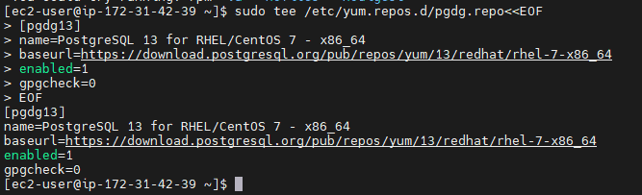

### 2. Run system update

sudo yum update

### 3. Command to install PostgreSQL on Amazon Linux 2

sudo yum install postgresql13 postgresql13-server

### 4. Initial database configurations

sudo /usr/pgsql-13/bin/postgresql-13-setup initdb

### 5. Enable and Start PostgreSQL Service

sudo systemctl start postgresql-13

sudo systemctl enable postgresql-13

**Check the status of the Service.**

sudo systemctl status postgresql-13

### 6. Secure PostgreSQL default Database

sudo passwd postgres

**Enter the password:root1234**

**Reenter the password:root1234**

**Login using Postgres system account-**

su - postgres

-bash-4.2$ psql

postgres=#

**Now, change the Admin database password-**

postgres=# \q

-bash-4.2$ psql -c "ALTER USER postgres WITH PASSWORD 'root1234';"

ALTER ROLE

-bash-4.2$ psql

postgres=#

website ref:- <https://www.how2shout.com/linux/install-postgresql-13-on-aws-ec2-amazon-linux-2/>

Docker:

Docker vs Vm deployments

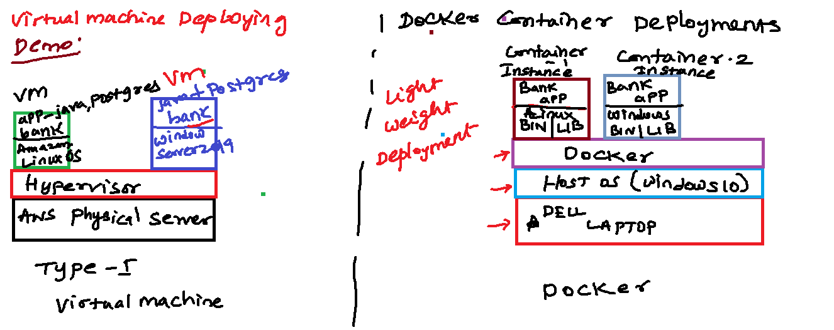

Steps to install docker on AWS EC2 amazon linux2:

sudo yum update -y

sudo yum install -y docker

sudo service docker start

sudo usermod -a -G docker ec2-user

Docker Commands:-

docker –version

docker info

How to dockerize or containerize your app:-

Step 1: create a spring boot rest api using sts or eclipse

Step 2: create a Dockerfile write container configuration

Projectfolder🡪 right click🡪 New 🡪 File 🡪 Enter the filename as Dockerfile-> paste the below commands

FROM openjdk:11

COPY ./target/yourjarfilename.jar yourjarfilename.jar

CMD ["java","-jar"," yourjarfilename.jar"]

Step 3: using a maven build create a jar file in projectfolder/target/yourjarfilename.jar

Step 4: Goto S3 service create a bucket make it as public bucket access then upload the jar

Step 5: Go into the remote of ec2 amazon linux instance

[root@ip-172-31-86-236 ec2-user]# aws configure

**[root@ip-172-31-86-236 ec2-user]# aws configure**

**AWS Access Key ID: [****************XW7Y]**

**AWS Secret Access Key: Th550cf5mPuW2QP8Yt6yX+DXEgnNk3ZP51Nduo4V**

**Default region name [None]: us-east-1**

**Default output format [None]: json**

**[root@ip-172-31-86-236 ec2-user]# aws s3 ls**

**It will list the bucket details**

Step 6: copy the bms.jar from s3 -> bankmanagement bucket to EC2 instance current directory

**[root@ip-172-31-86-236 ec2-user]# aws s3 cp s3://tmsnovel/trainmanagementsystem/ . --recursive**

**[root@ip-172-31-86-236 ec2-user]# ls -a**

**. .bash_history .bash_profile bms.jar**

**.. .bash_logout .bashrc .ssh**

**Create an image from the dockerfile command:-**

**===============================================**

**Docker build 🡪 Docker Engine 🡪 It will read the Dockerfile and it will create an image inside the Local Image registry**

**Command Syntax:-**

**Docker build –t tagname –f Dockerfile locationofthedocker**

Eg:-

Docker build –t traineetms –f Dockerfile .

**To View the images available in local Image Registry command:-**

**==============================================================**

**Command Syntax:-**

**Docker images**

Eg:-

Docker images

REPOSITORY TAG IMAGE ID CREATED SIZE

traineetms latest aab327edc8fe 32 seconds ago 677MB

**To delete an image from local Image Registry command:-**

**==============================================================**

**Command Syntax:-**

**Docker image rm imagename/imageid**

Eg:-

Docker image rm traineetms

REPOSITORY TAG IMAGE ID CREATED SIZE

traineetms latest aab327edc8fe 32 seconds ago 677MB

Container Commands:-

**How to create a container from the docker image:-**

**Docker run -> it will create an container from the image**

**Also it will run application inside that container**

**Command Syntax:-**

**Docker run –-name containername –p runningportno:appportno imagenameorID**

Eg:-

Docker run –name tmscontainer –p 8182:8080 aab327edc8fe

Command to view the containers

docker ps